Admission of States to the Union
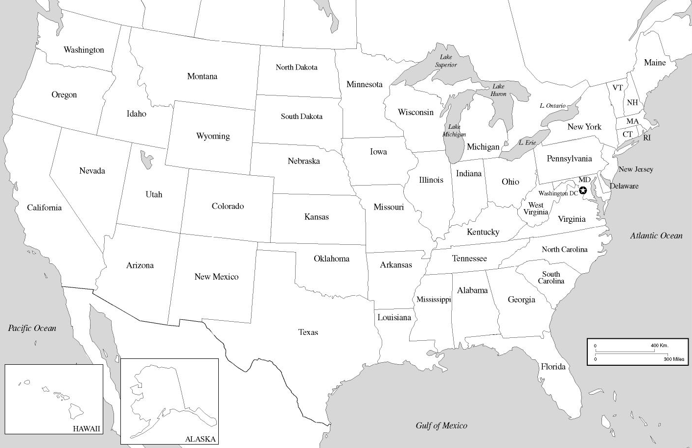
Directions
- Use the chart on the next page to label each state with its date of admission to the Union (year only)
- Color-code your map as follows: Blue: 13 original states; Green: Post-Independence states; Yellow: Manifest Destiny/Antebellum/Civil War; Orange: Post-Civil War; Red: Recent Admissions

 | State | Date Admitted | Color
1 | Delaware | Dec. 7, 1787 | Blue
2 | Pennsylvania | Dec. 12, 1787 | Blue
3 | New Jersey | Dec. 18, 1787 | Blue
4 | Georgia | Jan. 2, 1788 | Blue
5 | Connecticut | Jan. 9, 1788 | Blue
6 | Massachusetts | Feb. 6, 1788 | Blue
7 | Maryland | April 28, 1788 | Blue
8 | South Carolina | May 23, 1788 | Blue
9 | New Hampshire | June 21, 1788 | Blue
10 | Virginia | June 25, 1788 | Blue
11 | New York | July 26, 1788 | Blue
12 | North Carolina | Nov. 21, 1789 | Blue
13 | Rhode Island | May 29, 1790 | Blue
14 | Vermont | March 4, 1791 | Green
15 | Kentucky | June 1,1792 | Green
16 | Tennessee | June 1, 1796 | Green
17 | Ohio | March 1, 1803 | Green
18 | Louisiana | April 30, 1812 | Green
19 | Indiana | Dec.11, 1816 | Green
20 | Mississippi | Dec.10, 1817 | Green
21 | Illinois | Dec.3, 1818 | Green
22 | Alabama | Dec.14, 1819 | Green
23 | Maine | March 15, 1820 | Green
24 | Missouri | Aug. 10, 1821 | Green
25 | Arkansas | June 15, 1836 | Green
26 | Michigan | Jan. 26, 1837 | Green
27 | Florida | March 3, 1845 | Green
28 | Texas | Dec.29, 1845 | Yellow
29 | Iowa | Dec.28, 1846 | Yellow
30 | Wisconsin | May 26, 1848 | Yellow
31 | California | Sept. 9, 1850 | Yellow
32 | Minnesota | May 11, 1858 | Yellow
33 | Oregon | Feb. 14, 1859 | Yellow
34 | Kansas | Jan. 29, 1861 | Yellow
35 | West Virginia | June 20, 1863 | Yellow
36 | Nevada | October 31, 1864 | Yellow
37 | Nebraska | March 1, 1867 | Orange
38 | Colorado | Aug. 1, 1876 | Orange
39 | North Dakota | Nov. 2, 1889 | Orange
40 | South Dakota | Nov. 2, 1889 | Orange
41 | Montana | Nov. 8, 1889 | Orange
42 | Washington | Nov. 11, 1889 | Orange
43 | Idaho | July 3, 1890 | Orange
44 | Wyoming | July 10, 1890 | Orange
45 | Utah | Jan. 4, 1896 | Orange
46 | Oklahoma | Nov. 16, 1907 | Orange
47 | New Mexico | Jan. 6, 1912 | Orange
48 | Arizona | Feb. 14, 1912 | Orange
49 | Alaska | Jan. 3, 1959 | Red
50 | Hawaii | Aug. 21, 1959 | Red

