APUSH Unit 2
Revolutionary Era
APUSH 2.1 – APUSH 3.3
VUS.4a – VUS.4d

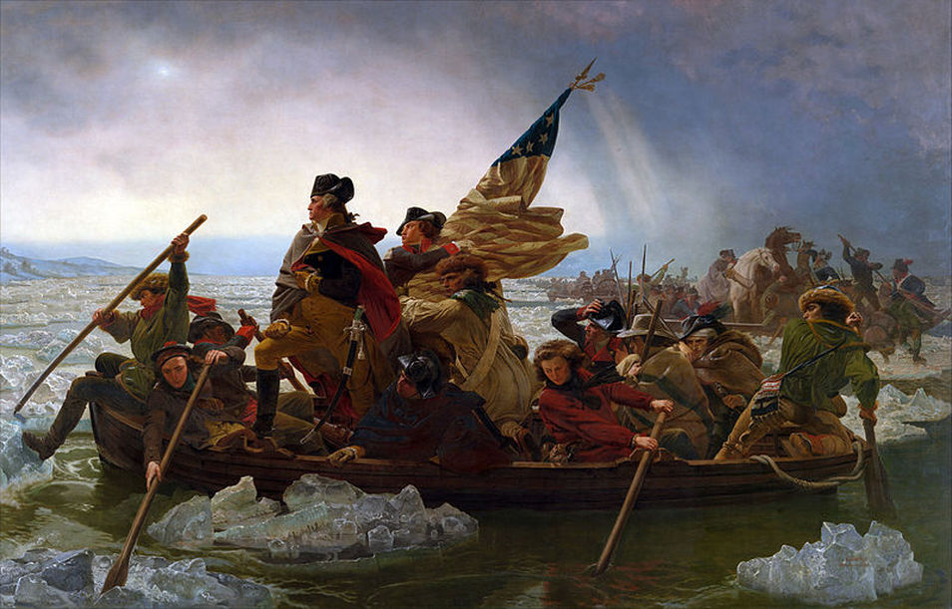

French Colonization

French colonists established a limited presence around the St. Lawrence River, Great Lakes, Acadia and Mississippi River.
- Seventeenth-century Spanish, French, Dutch, and British colonizers embraced different social and economic goals, cultural assumptions, and folkways, resulting in varied models of colonization.
- French and Dutch colonial efforts involved relatively few Europeans and used trade alliances and intermarriage with American Indians to acquire furs and other products for export to Europe.

Catholics
Huguenots
Edict of Nantes
“New France”
Quebec, Montreal, Detroit, New Orleans
Samuel de Champlain
St. Lawrence River
Great Lakes
Acadia
Robert La Salle
Mississippi River
“Louisiana”
Huron Indians
Small-scale settlement
Coureurs de bois
Voyageurs
Intermarriage with Indians
Beaver pelts
Jesuits

French & Indian War

Competition over resources between European rivals led to conflict within and between North American colonial possessions and American Indians.
- Conflicts in Europe spread to North America, as French, Dutch, British, and Spanish colonies allied, traded with, and armed American Indian groups, leading to continuing political instability.
- European colonization efforts in North America stimulated intercultural contact and intensified conflict between the various groups of colonizers and native peoples.
- By supplying American Indian allies with deadlier weapons and alcohol, and by rewarding Indian military actions, Europeans helped increase the intensity and destructiveness of American Indian warfare.
- English population growth and expansion into the interior disrupted existing French–Indian fur trade networks and caused various Indian nations to shift alliances among competing European powers.
- Throughout the second half of the 18th century, various American Indian groups repeatedly evaluated and adjusted their alliances with Europeans, other tribes, and the new United States government.
- After the British defeat of the French, white–Indian conflicts continued to erupt as native groups sought both to continue trading with Europeans and to resist the encroachment of British colonists on traditional tribal lands.
- Britain’s victory over France in the imperial struggle for North America led to new conflicts among the British government, the North American colonists, and American Indians, culminating in the creation of a new nation, the United States.
- The French withdrawal from North America and the subsequent attempt of various native groups to reassert their power over the interior of the continent resulted in new white–Indian conflicts along the western borders of British and, later, the U.S. colonial settlement and among settlers looking to assert more power in interior regions.

Britain-France-Spain
War of the League of Augsburg (King William’s War)
War of Spanish Succession (Queen Anne’s War)
War of Austrian Succession (King George’s War)
War of Jenkins’ Ear
Seven Years War (French & Indian War)
(War of the) American Revolution
Ohio River Valley
Colonel George Washington
Fort Duquesne & Fort Necessity
Iroquois Confederacy
Albany Plan of Union (Albany Congress)
Benjamin Franklin
“Join or Die”
Colonial militia
British regulars
Edward Braddock
William Pitt
James Wolfe
Battle of Quebec
Treaty of Paris of 1763
Acadia (Nova Scotia)
Cajuns
Pontiac’s Rebellion, 1763
Smallpox
Proclamation (Line) of 1763
Appalachian Mountains
Paxton Boys

Colonial Discontent

Britain’s desire to maintain a viable North American empire in the face of growing internal challenges and external competition inspired efforts to strengthen its imperial control, stimulating increasing resistance from colonists who had grown accustomed to a large measure of autonomy.
- The increasing political, economic, and cultural exchanges within the “Atlantic World” had a profound impact on the development of colonial societies in North America.
- “Atlantic World” commercial, religious, philosophical, and political interactions among Europeans, Africans, and American native peoples stimulated economic growth, expanded social networks, and reshaped labor
- systems.
- The growth of an Atlantic economy throughout the 18th century created a shared labor market and a wide exchange of New World and European goods, as seen in the African slave trade and the shipment of products from the Americas.
- As European nations competed in North America, their colonies focused on gaining new sources of labor and on producing and acquiring commodities that were valued in Europe.
- The goals and interests of European leaders at times diverged from those of colonial citizens, leading to growing mistrust on both sides of the Atlantic, as settlers, especially in the English colonies, expressed dissatisfaction over territorial settlements, frontier defense, and other issues.
- Late 17th-century efforts to integrate Britain’s colonies into a coherent, hierarchical imperial structure and pursue mercantilist economic aims met with scant success due largely to varied forms of colonial resistance and conflicts with American Indian groups, and were followed by nearly a half-century of the British government’s relative indifference to colonial governance.
- During and after the imperial struggles of the mid-18th century, new pressures began to unite the British colonies against perceived and real constraints on their economic activities and political rights, sparking a colonial independence movement and war with Britain.
- Great Britain’s massive debt from the Seven Years’ War resulted in renewed efforts to consolidate imperial control over North American markets, taxes, and political institutions — actions that were supported by some colonists but resisted by others.
- The French withdrawal from North America and the subsequent attempt of various native groups to reassert their power over the interior of the continent resulted in new white–Indian conflicts along the western borders of British and, later, the U.S. colonial settlement and among settlers looking to assert more power in interior regions.

Proclamation (Line) of 1763
Paxton Boys
Salutary neglect
Mercantilism
Favorable balance of trade
Currency
Royal veto
Smuggling
Writs of assistance
Regulator movement
George Grenville
Navigation Laws of 1763
Sugar Act of 1764
Quartering Act of 1765
Stamp Act of 1765
Admiralty courts
James Otis
“No taxation without representation”
“Virtual representation”
Stamp Act Congress
Boycott
Nonimportation agreements
Domestic economy
Sons of Liberty & Daughters of Liberty
Repeal of Stamp Act
Declaratory Act of 1766
Charles Townshend
Townshend Acts
John Dickinson
Letters from a Pennsylvania Farmer
Lord North
“Redcoats”/“Lobsterbacks”
Boston Massacre, 1770
Samuel Adams
Committees of Correspondence
British East India Company
Monopoly
Boston Tea Party, 1773
Coercive (“Intolerable”) Acts of 1774
Boston Port Act
Mercy Otis Warren
Town meetings
Jury of peers
New Quartering Act
Quebec Act
First Continental Congress
Declaration of Rights
The Association
“Nonimportation, nonexportation
nonconsumption”
Tarring and feathering
Patrick Henry
“Give me liberty or give me death”
Battles of Lexington & Concord
“Shot Heard ‘Round the World”
Second Continental Congress
Olive Branch Petition
George III
Richard Henry Lee
Thomas Jefferson
Declaration of Independence

Declaring Independence

Resistance to imperial control in the British colonies drew on colonial experiences of self-government, evolving local ideas of liberty, the political thought of the Enlightenment, greater religious independence and diversity, and an ideology critical of perceived corruption in the imperial system.
- Several factors promoted Anglicization in the British colonies: the growth of autonomous political communities based on English models, the development of commercial ties and legal structures, the emergence of a trans-Atlantic print culture, Protestant evangelism, religious toleration, and the spread of European Enlightenment ideas.
- As regional distinctiveness among the British colonies diminished over time, they developed largely similar patterns of culture, laws, institutions, and governance within the context of the British imperial system.
- The independence movement was fueled by established colonial elites, as well as by grassroots movements that included newly mobilized laborers, artisans, and women, and rested on arguments over the rights of British subjects, the rights of the individual, and the ideas of the Enlightenment.
- Protestant evangelical religious fervor strengthened many British colonists’ understandings of themselves as a chosen people blessed with liberty, while Enlightenment philosophers and ideas inspired many American political thinkers to emphasize individual talent over hereditary privilege.
- New political ideas about the relationship between people and their government helped to justify the Declaration of Independence.
- The American Revolution was inspired by ideas concerning natural rights and political authority, and its successful completion affected people and governments throughout the world for many generations.
- The revolutionary generation formulated the political philosophy and laid the institutional foundations for the system of government under which Americans live.

American identity
English culture
Protestantism
Taverns
Printing presses
John Peter Zenger Trial
Scientific Revolution
Deism
The Enlightenment
Radical Whigs
Thomas Hobbes
“State of nature”
Absolute monarchy
John Locke
“Natural rights”
“Life, liberty and property”
“Ordered liberty”
Jean-Jacques Rousseau
“Social contract”
“Consent of the governed”
Mercantilism
“No taxation without representation”
“Virtual representation”
Montesquieu
Separation of powers
Voltaire
Religious toleration
Separation of church and state
Thomas Paine
Common Sense
Republicanism
Democracy
Town meetings
Civic virtue
“Natural aristocracy”
Adam Smith
The Wealth of Nations
Capitalism
Richard Henry Lee
Thomas Jefferson
Declaration of Independence
Equality
“Inalienable rights”
“Life, liberty and the pursuit of happiness”
List of Grievances

Revolutionary War

Despite considerable loyalist opposition, as well as Great Britain’s apparently overwhelming military and financial advantages, the patriot cause succeeded because of the colonists’ greater familiarity with the land, their resilient military and political leadership, their ideological commitment, and their support from European allies.
- George Washington avoided any situation that threatened the destruction of his army, and his leadership kept the army together when defeat seemed inevitable.
- Benjamin Franklin successfully negotiated a Treaty of Alliance with France following the Patriot victory at the Battle of Saratoga.
- The American rebels had a firm belief in their cause. In contrast, the war did not have popular support in Great Britain.
- The British government grew tired of the struggle after the French agreed to aid the Americans.
- Americans benefited from the presence of the French army and navy at the Battle of Yorktown, which ended the war with an American victory.

Patriots (Whigs)
Loyalists (Tories)
Neutrals
Lord Dunmore’s Proclamation
Baron von Steuben
Marquis de Lafayette
Anglican Church
Congregational (Puritan) Church
Presbyterian Church
Continental Congress
Continental Army
General George Washington
Battle of Breed’s/Bunker Hill
Hessians (mercenaries)
Battle of Quebec, 1776
Thomas Paine
Common Sense
Guerilla warfare
War of attrition
John Howe
John Burgoyne
Battle of Saratoga, 1777
Benjamin Franklin
Model Treaty
Franco-American Alliance, 1778
Comte de Rochambeau
French soldiers
Admiral de Grasse
French navy
Armed Neutrality League
Iroquois Confederacy
George Rogers Clark
Privateers
John Paul Jones
Nathanael Greene
Charles Cornwallis
Battle of Yorktown, 1781
Resignation of Lord North
Paris Peace negotiations
Franklin, Jay & Adams
Treaty of Paris, 1783

Impact of the American Revolution

British imperial attempts to reassert control over its colonies and the colonial reaction to these attempts produced a new American republic, along with struggles over the new nation’s social, political, and economic identity.
- While the new governments continued to limit rights to some groups, ideas promoting self-government and personal liberty reverberated around the world.
- The ideals expressed in the Declaration of Independence contradicted the realities of slavery and the undemocratic nature of political participation in the early decades of the new republic.
- During and after the American Revolution, an increased awareness of the inequalities in society motivated some individuals and groups to call for the abolition of slavery and greater political democracy in the new state and national governments.
- Enlightenment ideas and women’s experiences in the movement for independence promoted an ideal of “republican motherhood,” which called on white women to maintain and teach republican values within the family and granted women a new importance in American political culture.
- Various tribes attempted to forge advantageous political alliances with one another and with European powers to protect their interests, limit migration of white settlers, and maintain their tribal lands.
- While the new governments continued to limit rights to some groups, ideas
- promoting self-government and personal liberty reverberated around the world.
- The American Revolution and the ideals set forth in the Declaration of Independence had reverberations in France, Haiti, and Latin America, inspiring future rebellions.

Patriots (Whigs)
Loyalists (Tories)
Neutrals
Confiscation of Loyalist property
Loyalist exodus
Manufacturing
Inflation
Property requirements for voting
Primogeniture, quitrents & entails
Disestablishment of religion
Thomas Jefferson’s Virginia Statute for Religious Freedom
Jefferson Bible
“Separation of church and state”
Lord Dunmore’s Proclamation
Gradual abolition in the north
Manumission in north & mid-Atlantic
Eli Whitney’s cotton gin
Expansion of slavery in the south
Abigail Adams
Republican motherhood
Civic virtue
State constitutions
Treaty of Fort Stanwix, 1784
Westward expansion
British Forts in Old Northwest
Spanish Florida & Louisiana
Repayment of French war loans
French Revolution
Haitian Revolution
Mexican independence
Gran Colombia

Unit Review: Essential Questions

- What characteristics defined French settlement in North America?
- How did the French & Indian War impact Native Americans, French settlers and British colonists?
- In what ways did the French & Indian War alter the political, economic and ideological relations between Britain and its American colonies?
- How and why did Britain attempt to increase its control over the colonies?
- How and why did colonists resist British control?
- How did the ideas of John Locke and Thomas Paine influence Jefferson’s writings in the Declaration of Independence?
- How did the Declaration of Independence become a road map for the new republic as it extended the franchise, provided for equality of opportunity, and guaranteed “unalienable rights”?
- What differences existed among Americans concerning separation from Great Britain?
- What factors contributed to the victory of the American rebels?
- How did the American Revolution affect the lives of women, African Americans, Native Americans, and British Loyalists?
- To what extent did the American Revolution fundamentally transform American society?

