APUSH Unit 3
Confederation & Constitution
APUSH 3.2 – APUSH 3.3
VUS.5a – VUS.5d

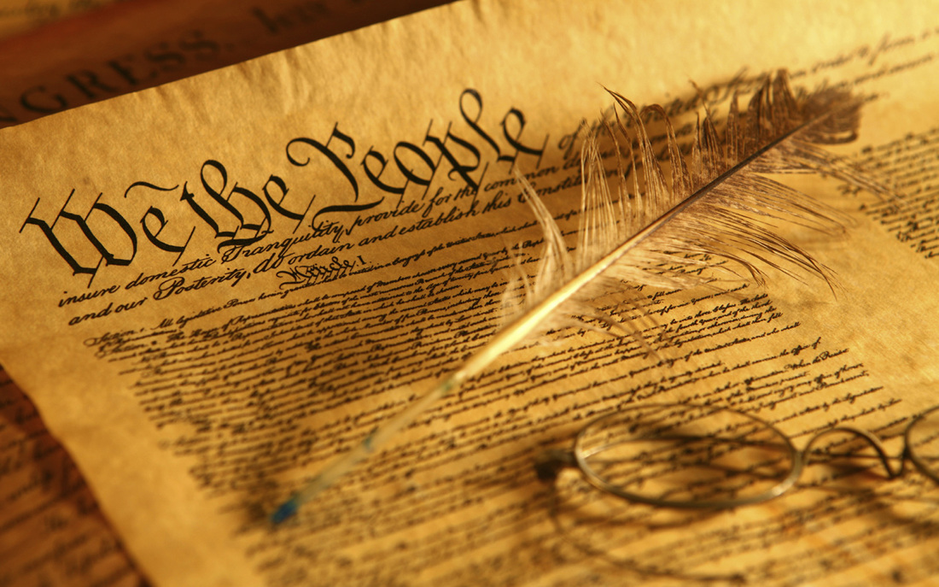

Review: Ideas of the Enlightenment

Thomas Hobbes
“State of nature”
Absolute monarchy
John Locke
“Natural rights”
“Life, liberty and property”
“Ordered liberty”
Jean-Jacques Rousseau
“Social contract”
“Consent of the governed”
Montesquieu
Separation of powers
Voltaire
Religious toleration
Separation of church and state
Thomas Paine
Common Sense
Republicanism
Democracy
Town meetings
Civic virtue
“Natural aristocracy”
Adam Smith
The Wealth of Nations
Capitalism
Richard Henry Lee
Thomas Jefferson
Declaration of Independence
Equality
“Inalienable rights”
“Life, liberty and the pursuit of happiness”

Articles of Confederation & State Governments

During the 18th century, new ideas about politics and society led to debates about religion and governance, and ultimately inspired experiments with new governmental structures.
- Many new state constitutions and the national Articles of Confederation, reflecting republican fears of both centralized power and excessive popular influence, placed power in the hands of the legislative branch and maintained property qualifications for voting and citizenship.
- Migrants from within North America and around the world continued to launch new settlements in the West, creating new distinctive backcountry cultures and fueling social and ethnic tensions.
- As settlers moved westward during the 1780s, Congress enacted the Northwest Ordinance for admitting new states and sought to promote public education, the protection of private property, and the restriction of slavery in the Northwest Territory.
- The policies of the United States that encouraged western migration and the orderly incorporation of new territories into the nation both extended republican institutions and intensified conflicts among American Indians and Europeans in the trans-Appalachian West.
- Difficulties over trade, finances, and interstate and foreign relations, as well as internal unrest, led to calls for significant revisions to the Articles of Confederation and a stronger central government.
- The major principles of the Bill of Rights of the Constitution were based on earlier Virginia statutes.

Virginia Declaration of Rights
George Mason
Virginia Statute for Religious Freedom
Thomas Jefferson
Disestablishment
State constitutions
Property requirements
Strong legislatures
Weak executives and judiciaries
State capitals
2nd Continental Congress
Articles of Confederation
Continental Army
Equal representation
Continental Army
Westward expansion and settlement
State boundary disputes
(Old) Northwest Territory
Land Ordinance of 1785
Public education
Slavery in the territories
Northwest Ordinance of 1787
Northwest Indian War
Admission of states to the union
Gradual abolition in the north
Weak government
States’ rights
Legislative branch
Equal representation
Supermajority
Unanimous
Taxation
Interstate commerce
Foreign trade tariffs
Currency problems
External threats
- Canada
- British forts
- Native Americans
- Spanish Florida
- Mississippi River navigation
- Barbary pirates
- Franco-American alliance & debt
Shays’ Rebellion

Constitutional Convention

After experiencing the limitations of the Articles of Confederation, American political leaders wrote a new Constitution based on the principles of federalism and separation of powers, crafted a Bill of Rights, and continued their debates about the proper balance between liberty and order.
- Delegates from the states worked through a series of compromises to form a Constitution for a new national government, while providing limits on federal power.
- The constitutional framers postponed a solution to the problems of slavery and the slave trade, setting the stage for recurring conflicts over these issues in later years.
- The Constitution’s failure to precisely define the relationship between American Indian tribes and the national government led to problems regarding treaties and Indian legal claims relating to the seizure of Indian lands.
- The Constitution of the United States established a government that shared power between the national government and state governments, protected the rights of states, and provided a system for orderly change through amendments to the Constitution itself.

Articles of Confederation, 1777
Shays’ Rebellion, 1787
Constitutional Convention, 1787
George Washington
Legislative branch
Executive branch
Judicial branch
James Madison
“Father of the Constitution”
Virginia Plan
New Jersey Plan
William Paterson
Great Compromise (Connecticut Compromise)
Roger Sherman
Senate
Equal representation
Appointment by state legislatures
House of Representatives
Proportional representation
Direct election by the people
Bicameral
Electoral College
Indirect election
Three Fifths Compromise
Compromise on trade
Slave trade
Imports & exports
Three branches
Checks and balances
Separation of powers
Taxation
Simple majority vote
Majority rule
Respect for the minority
Federalism
Central authority
National supremacy
States’ rights
Preamble
Article I
Article II
Article III
Article IV
Article V
Article VI
Article VII
Ratification
Federalists
Antifederalists
Bill of Rights

Three Branches

The powers of the United States federal government are divided between the legislative, executive and judicial branches.

Article I
Legislative branch
House of Representatives
Senate
Three Fifths Compromise
Census
Apportionment
Gerrymandering
Impeachment
Treaty ratification
Confirmation hearings
Veto override
“Power of the purse”
Revenue & appropriation
Power to declare war
Interstate commerce clause
Majority rule
Supermajority
Filibuster
Enumerated powers
Implied powers
Necessary & proper (elastic) clause
Habeas corpus
Bill of attainder
Ex post facto law
Titles of nobility
Congressional oversight
Article II
Executive branch
President
Vice president
Electoral college
Inauguration
Oath of office
Chief executive
Enforcement of law
Head of state
Commander-in-chief
Veto
Pocket veto
Pardon
Treaty negotiations
Appointment of judges
State of the Union address
Impeachment of the president
Article III
Judicial branch
Supreme Court
Chief Justice
Original jurisdiction
Appellate jurisdiction
Interpretation of law
Precedent (stare decisis)
Treason
Article IV
Full faith and credit
Extradition
Fugitive slave clause
Article V
Amendment
Article VI
National supremacy
Treaties
Religious test
Article VII
Ratification
Checks & balances
Separation of powers
Federalism

Ratification & Bill of Rights

Federalists and Anti-Federalists debated whether it was possible for a republic to govern a large geographic area.
- Federalists argued that a strong central government was necessary while Anti-Federalists argued that such a government would violate the rights of the states and the people.
- The Bill of Rights was drafted to allay the fears of the Anti-Federalists.
- The major principles of the Bill of Rights of the Constitution were based on earlier Virginia statutes.
- Elements of Federalist and Anti-Federalist thought are reflected in contemporary political debate on issues such as the size and role of government, federalism, and the protection of individual rights.

Athenian democracy
Roman Republic
Roman Empire
Article VII
Ratification
Federalists
Federalist Papers
John Jay, Alexander Hamilton & James Madison
“Publius”
Conservatism
“Counterrevolution”
Antifederalists
Antifederalist Papers
George Mason
Patrick Henry
“Brutus”
Virginia Declaration of Rights
George Mason
Virginia Statute for Religious Freedom
Thomas Jefferson
Disestablishment
Bill of Rights
1st Amendment
RAPPS
Free exercise of religion
Establishment of religion
2nd Amendment
Right to bear arms
3rd Amendment
Quartering of soldiers
4th Amendment
Probable cause & search warrants
5th Amendment
Rights of the accused
Double jeopardy
Self-incrimination
Due process
6th Amendment
Speedy, public trial
Jury trial
Assistance of counsel
7th Amendment
Civil lawsuits
8th Amendment
Excessive bail & fines
Cruel & unusual punishment
9th Amendment
Non-enumerated rights
10th Amendment
Reserved powers
Modern debates about…
- “Big government”
- Welfare state
- States’ rights
- Individual liberty
- Etc.

Unit Review: Essential Questions

- How did America’s pre-Revolutionary relationship with England influence the structure of the first national government?
- What weaknesses in the Articles of Confederation led to the effort to draft a new constitution?
- How did the delegates to the Constitutional Convention balance competing interests?
- What are the underlying principles of the American system of government?
- What is the relationship between the three branches of government? Between the national government and the states?
- How was the Bill of Rights influenced by the Virginia Declaration of Rights and the Virginia Statute for Religious Freedom?
- What were the major arguments for and against the Constitution of 1787 in leading Federalist and Anti-Federalist writings and in the ratification debates?

