APUSH Unit 5
Expansion, Reform & Sectionalism
APUSH 4.1 – APUSH 5.2
VUS.5e, VUS.6b, VUS.6d, VUS.6e, VUS.7a

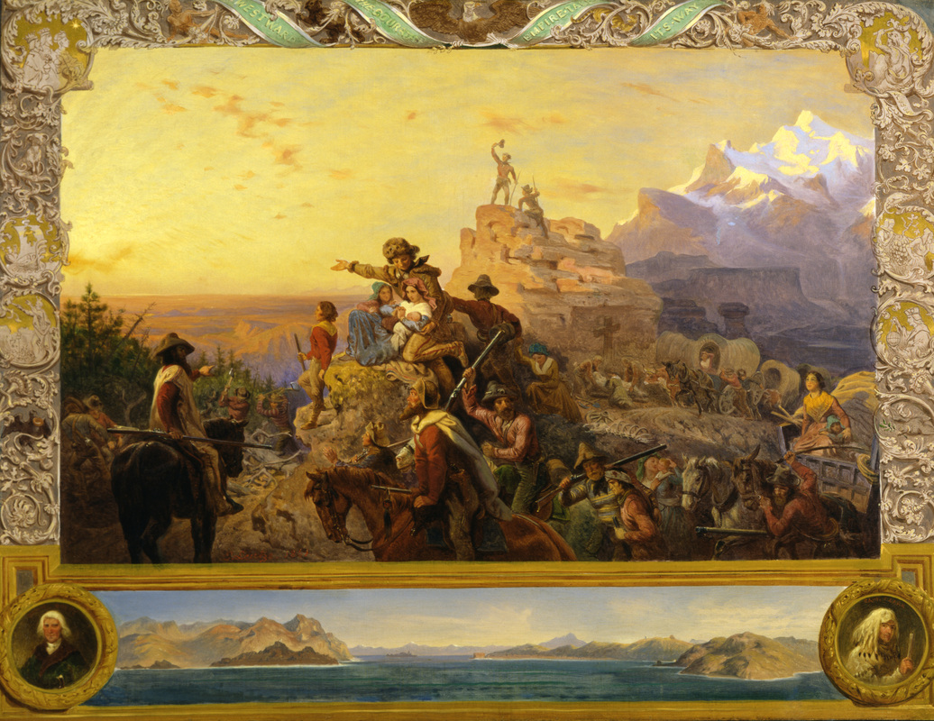

Jacksonian Democracy

The United States developed the world’s first modern mass democracy and celebrated a new national culture, while Americans sought to define the nation’s democratic ideals and to reform its institutions to match them.
- As national political institutions developed in the new United States, varying regionally based positions on economic, political, social, and foreign policy issues promoted the development of political parties.
- An extension of the franchise, westward expansion, and the rise of sectional interests prompted increased participation in state and national politics.
- As various constituencies and interest groups coalesced and defined their agendas, various political parties, most significantly the Democrats and Whigs in the 1830s, were created or transformed to reflect and/or promote those agendas.
- Regional interests continued to trump national concerns as the basis for many political leaders’ positions on economic issues including slavery, the national bank, tariffs, and internal improvements.
- The Adams administration lacked popular support, ending the Era of Good Feeling.
- The Jacksonian Era brought democratic changes that benefitted the “common man,” though Jackson himself was an autocratic leader.
- Federal government attempts to assert authority over the states brought resistance from state governments in the North and the South at different times.
- The nation’s transformation to a more participatory democracy was accompanied by continued debates over federal power, the relationship between the federal government and the states, the authority of different branches of the federal government, and the rights and responsibilities of individual citizens.
- Resistance to initiatives for democracy and inclusion included proslavery arguments, anti-black sentiments in political and popular culture, and restrictive anti-Indian policies.
- The Constitution’s failure to precisely define the relationship between American Indian tribes and the national government led to problems regarding treaties and Indian legal claims relating to the seizure of Indian lands.
- Conflicts between American settlers and Indian nations in the Southeast and the old Northwest resulted in the relocation of many Indians to reservations.
- Post-Jacksonian presidents carried forth many Jacksonian policies, but with less popular success.

John Quincy Adams Administration
Era of Good Feeling
Election of 1824
Corrupt bargain
Whig Party
Henry Clay’s American System
Treaty of Indian Springs

Andrew Jackson Administration
Election of 1828
Universal white manhood suffrage
“Common man”
“Poor white trash”
Second Party System
Democratic Party
Whig Party
Direct Democracy
Autocracy
“King Mob” vs. “King Caucus”
Stump speeches
Voter turnout
Spoils system
Petticoat (Peggy Eaton) Affair
Parlor Cabinet vs. Kitchen Cabinet
John C. Calhoun
Martin Van Buren
Maysville Road veto
Protectionism/protective tariffs
1828 Tariff (“of Abominations”)
Nullification
Sectionalism
South Carolina Exposition & Protest
Daniel Webster-Robert Hayne debate
Force Bill
Henry Clay
(Compromise) Tariff of 1833
Second Bank of the United States
Bank War
Nicholas Biddle
Pet banks
Specie circular
Hard money & soft money
Panic of 1837
Creek War
Seminole Campaign
Five Civilized Tribes
Indian Removal Act
Cherokee Nation v. Georgia
Worchester v. Georgia
Black Hawk
Osceola
Trail of Tears
Alexis de Tocqueville’s Democracy in America

Van Buren, Harrison & Tyler Administrations
Texas War for Independence
Texas Annexation
Aroostook War
Webster-Ashburton Treaty
Martin Van Buren
“Martin Van Ruin”
Second Party System
Whig Party
William Henry Harrison
“Tippecanoe & Tyler Too”
John Tyler
“Log Cabin & Hard Cider”

The National Economy

A global market and communications revolution, influencing and influenced by technological innovations, led to dramatic shifts in the nature of agriculture and manufacturing.
- Despite some governmental and private efforts to create a unified national economy, most notably the American System, the shift to market production linked the North and the Midwest more closely than either was linked to the South.
- Transportation networks and the growth of markets increased the interdependency of the nation’s industrial and agricultural economies.
- Regional economic specialization, especially the demands of cultivating southern cotton, shaped settlement patterns and the national and international economy.
- Southern cotton furnished the raw material for manufacturing in the Northeast, while the growth in cotton production and trade promoted the development of national economic ties, shaped the international economy, and fueled the internal slave trade.
- With the opening of canals and new roads into the western territories, native-born white citizens relocated westward, relying on new community systems to replace their old family and local relationships.
- Innovations including textile machinery, steam engines, interchangeable parts, canals, railroads, and the telegraph, as well as agricultural inventions, both extended markets and brought efficiency to production for those markets.
- The market revolution helped to widen a gap between rich and poor, shaped emerging middle and working classes, and caused an increasing separation between home and workplace.
- Increasing numbers of Americans, especially women in factories and low-skilled male workers, no longer relied on semi-subsistence agriculture but made their livelihoods producing goods for distant markets, even as some urban entrepreneurs went into finance rather than manufacturing.
- Developments in technology, agriculture, and commerce precipitated profound changes in U.S. settlement patterns, regional identities, migration patterns, gender and family relations, and the distribution of economic and political power.
- Migrants from Europe increased the population in the East and the Midwest, forging strong bonds of interdependence between the Northeast and the Old Northwest.
- Substantial numbers of new international migrants — who often lived in ethnic communities and retained their religion, language, and customs — entered the country prior to the Civil War, giving rise to a major, often violent nativist movement that was strongly anti-Catholic and aimed at limiting immigrants’ cultural influence and political and economic power.
- Resistance to initiatives for democracy and inclusion included rising xenophobia.
- With the acceleration of a national and international market economy, Americans debated the scope of government’s role in the economy, while diverging economic systems meant that regional political and economic loyalties often continued to overshadow national concerns.
- Efforts to exploit the nation’s natural resources led to government efforts to promote free and forced migration of various American peoples across the continent, as well as to competing ideas about defining and managing labor systems, geographical boundaries, and natural resources.
- U.S. interest in increasing foreign trade, expanding its national borders, and isolating itself from European conflicts shaped the nation’s foreign policy and spurred government and private initiatives.

National economic interdependence
Regional economic differences
Marshall Court
Property rights
Sanctity of contracts
Interstate commerce clause
Corporations
Fletcher v. Peck, 1810
McCulloch v. Maryland, 1819
Dartmouth College v. Woodward, 1819
Gibbons v. Ogden, 1823
Taney Court
Charles River Bridge v. Warren Bridge, 1837
Andrew Jackson & the “Bank War”
Nationalism
Transportation Revolution
Henry Clay’s American System
Tariff of 1816
Second Bank of the United States
Internal improvements
Jackson’s veto of Maysville Road
Cumberland (National) Road
Turnpikes
Erie Canal
Clipper ships
Pony Express
Commercial (Market) Revolution
Industrial Revolution
Patents
Limited liability
Eli Whitney
Interchangeable parts
Cotton gin
“King Cotton”
Chattel slavery
Depletion of the soil
Westward expansion
Expansion of slavery
James Watt
Steam engine
Railroads
Robert Fulton
Steam ship
Steam shovel
Anthracite coal mining
James Hargreaves
Spinning jenny
Samuel Slater
Factories
Waltham System
Company town
Paternalism
“Industrial utopianism”
Lowell, Massachusetts
Mill girls
Textile industry
Isaac Singer & Elias Howe
Sewing machine
Corporations
“Wage slavery”
Child labor
Labor unions
Samuel F.B. Morse
Telegraph
John Deere
Steel plow
Cyrus McCormick
Mechanized reaper
Social mobility
Middle class
Urbanization
German immigrants
Adolphus Busch, Frederick Pabst, Joseph Schlitz, Frederick Miller
Irish immigrants
Irish Potato Famine
N.I.N.A. (“No Irish need apply”)
Nativism & xenophobia
“Anti-Papism”
American (Know-Nothing) Party

Religious & Reform Movements

The Second Great Awakening, liberal social ideas from abroad, and Romantic beliefs in human perfectibility fostered the rise of voluntary organizations to promote religious and secular reforms.
- Americans began struggling with how to match democratic political ideals to political institutions and social realities.
- Religious participation became more democratic and new religious and philosophical movements were born.
- Major reform movements of the mid-19th century included the expansion of educational opportunities, mental health care, prison reform, temperance, abolitionism and women’s rights.
- Women played a leading role in religious and reform movements.

Second Great Awakening
Revivals & camp meetings
“Burned-Over District”
Charles G. Finney
Southern Baptist Convention
Unitarianism
Methodism
John Wesley
Millennialism/Millenarianism
Millerites/Adventists
Shakers
Mormons/Latter Day Saints
Joseph Smith
Brigham Young
Salt Lake City
Polygamy
Debate over Utah statehood
African Methodist Episcopal (AME) Church
Horace Mann
Public education
Webster’s Dictionary
McGuffey’s Readers
Lyceums
Penal (prison) reform
Capital punishment
Penitentiaries & reformatories
Dorothea Dix
Asylum movement
Pacifism
“Republican motherhood”
Alcoholism, infidelity, domestic abuse and sexually-transmitted (venereal) diseases
Temperance & prohibition movements
Ten Nights in a Barrroom
Carrie Nation
Maine Law & “Blue Laws”
Catherine Beecher
Lyman Beecher
Emma Willard
“Cult of Domesticity”
Elizabeth Cady Stanton
Lucretia Mott
Seneca Falls Convention & Declaration of Sentiments
Susan B. Anthony
Elizabeth Blackwell
Amelia Bloomer
Utopian Communities
“Bible Communism”
Shakers
Mother Ann Lee
Celibacy
Gender separation
Simplicity
New Harmony
Robert Owen
Utopian socialism
Brook Farm
Charles Fourier
Transcendentalism
“Oversoul”
Ralph Waldo Emerson
Henry David Thoreau
Civil Disobedience
Margaret Fuller
John Humphrey Noyes
Oneida Community
“Complex marriage”
Artisans

The Antebellum South & Abolitionism

The institution of slavery and its attendant ideological debates, along with regional economic and demographic changes, territorial expansion in the 1840s and 1850s, and cultural differences between the North and the South, all intensified sectionalism.
- Despite the outlawing of the international slave trade, the rise in the number of free African Americans in both the North and the South, and widespread discussion of various emancipation plans, the U.S. and many state governments continued to restrict African Americans’ citizenship possibilities.
- The expansion of slavery in the lower South and adjacent western lands, and its gradual disappearance elsewhere, began to create distinctive regional attitudes toward the institution.
- The North’s expanding economy and its increasing reliance on a free-labor manufacturing economy contrasted with the South’s dependence on an economic system characterized by slave-based agriculture and slow population growth.
- Federal government attempts to assert authority over the states brought resistance from state governments in the North and the South at different times.
- Many white Americans in the South asserted their regional identity through pride in the institution of slavery, insisting that the federal government should defend that institution.
- States’ rights, nullification, and racist stereotyping provided the foundation for the Southern defense of slavery as a positive good.
- Resistance to initiatives for democracy and inclusion included proslavery arguments and anti-black sentiments in political and popular culture.
- Enslaved and free African Americans, isolated at the bottom of the social hierarchy, created communities and strategies to protect their dignity and their family structures, even as some launched abolitionist and reform movements aimed at changing their status.
- Opposition to slavery grew stronger in the mid-1800s, thanks to a movement led by former slaves and white sympathizers.
- Abolitionists, although a minority in the North, mounted a highly visible campaign against slavery, adopting strategies of resistance ranging from fierce arguments against the institution and assistance in helping slaves escape to willingness to use violence to achieve their goals.
- The South remained politically, culturally, and ideologically distinct from the other sections, while continuing to rely on its exports to Europe for economic growth.

Three-Fifths Compromise
Compromise on Trade
Fugitive Slave Clause
Slave Importation Act, 1808
British abolition of Atlantic slave trade
Mason-Dixon Line
Eli Whitney
Cotton gin
“King Cotton”
Cotton exports to Europe
Northern textile industry
Tobacco
Indigo
Rice
“Peculiar institution”
“Necessary evil”
Internal slave trade
Chattel slavery
Breakers & drivers
Plantation system
Monoculture farming
Slow population growth & low levels of immigration
Depletion of soil
Louisiana Purchase
Missouri Compromise
Field slaves
Domestic slaves
Artisan slaves
Sexual violence against slaves
Sally Hemings controversy
“Mulattoes”
Legal status of mixed-race children
Slave marriages
Call-and-response
Free blacks
Aristocracy
Poor whites
Yeoman farmers
Tallmadge Amendment
10th Amendment
States’ rights
Nullification
Southern Baptist Convention
Biblical justifications for slavery
Thomas Jefferson’s Notes on Virginia
George Fitzhugh’s Sociology of the South
Minstrel shows
Gullah
Malingering
Sabotage
Fugitive slaves
Gabriel Prosser
Denmark Vesey
Nat Turner
Amistad case
American Colonization Society
Liberia
Arthur & Lewis Tappan
Grimke Sisters
American Antislavery Society
William Lloyd Garrison
The Liberator
David Walker’s Appeal
Gag Resolution
Frederick Douglass
Narrative of the Life of Frederick Douglass
The North Star
Harriet Beecher Stowe
Uncle Tom’s Cabin
John Brown
Hinton R. Helper
The Impending Crisis of the South
Elijah P. Lovejoy
Sojourner Truth
“Ain’t I a Woman?”
Harriet Tubman
Underground Railroad
Fugitive Slave Act of 1850
Personal liberty laws
Liberty Party
Free Soil Party
Republican Party

Westward Expansion

Economic and strategic interests, supported by popular beliefs, led to territorial expansion of the United States toward the Pacific Ocean in the 1800s.
- As over-cultivation depleted arable land in the Southeast, slaveholders relocated their agricultural enterprises to the new Southwest, increasing sectional tensions over the institution of slavery and sparking a broad-scale debate about how to set national goals, priorities, and strategies.
- Struggling to create an independent global presence, U.S. policymakers sought to dominate the North American continent and to promote its foreign trade. The U.S. sought dominance over the North American continent through a variety of means, including military actions, judicial decisions, and diplomatic efforts.
- The idea of Manifest Destiny, which asserted U.S. power in the Western Hemisphere and supported U.S. expansion westward, was built on a belief in white racial superiority and a sense of American cultural superiority, and helped to shape the era’s political debates. Whites living on the frontier tended to champion expansion efforts, while resistance by American Indians led to a sequence of wars and federal efforts to control American Indian populations.
- Following the Louisiana Purchase, the drive to acquire, survey, and open up new lands and markets led Americans into numerous initiatives in the Western Hemisphere and Asia. The 1820 Missouri Compromise created a truce over the issue of slavery that gradually broke down as confrontations over slavery became increasingly bitter. U.S. victory in the Mexican-American War was accompanied by a heated controversy over allowing or forbidding slavery in newly acquired territories.
- The nation struggled to resolve sectional issues, producing a series of crises and compromises. These crises took place over the admission of new states to the Union during the decades before the Civil War. The issue was whether the number of “free states” and “slave states” would remain balanced, thus affecting the distribution of power in the Congress.
- U.S. interest in expanding trade led to economic, diplomatic, and cultural initiatives westward to Asia.

Ecological imperialism
Self-reliance
Louisiana Purchase, 1803
War of 1812
Adams-Onis Treaty
Missouri Compromise (Compromise of 1820)
“Firebell in the Night”
Monroe Doctrine
Frederick Jackson Turner
Frontier Thesis
Stephen Austin
Texas War for Independence
The Alamo
Treaty of San Jacinto
Lone Star Republic
Annexation of Texas
Aroostook War
Webster-Ashburton Treaty
John L. O’Sullivan
Manifest Destiny
James K. Polk
Oregon Country
“Fifty Four Forty or Fight”
Nueces River
Rio Grande
Mexican War
Spot resolutions
Wilmot Proviso
Henry David Thoreau
Civil Disobedience
Zachary Taylor
Winfield Scott
Bear Flag Revolt
Treaty of Guadalupe Hidalgo
Mexican Cession
Great Triumvirate
Compromise of 1850
California statehood
Popular sovereignty
Fugitive Slave Act
California Gold Rush
49ers
Comstock Lode
Gadsden Purchase
William Walker
Ostend Manifesto
Clipper ships
Matthew Perry
Treaty of Kanagawa
Treaty of Wanghia

Sectional Crises of the 1850s

In the 1850s, sectional disagreements intensified and compromises failed as the nation hurtled toward civil war.
- Federal government attempts to assert authority over the states brought resistance from state governments in the North and the South at different times.
- Regional interests continued to trump national concerns as the basis for many political leaders’ positions on economic issues including slavery, the national bank, tariffs, and internal improvements.
- National leaders made a variety of proposals to resolve the issue of slavery in the territories, including the Compromise of 1850, the Kansas–Nebraska Act, and the Dred Scott decision, but these ultimately failed to reduce sectional conflict.
- The second party system ended when the issues of slavery and anti-immigrant nativism weakened loyalties to the two major parties and fostered the emergence of sectional parties, most notably the Republican Party in the North and the Midwest.
- Lincoln’s election on a free soil platform in the election of 1860 led various Southern leaders to conclude that their states must secede from the Union, precipitating civil war.

Compromise of 1850
California statehood
Popular sovereignty
Fugitive Slave Act of 1850
James Buchanan
Free-Soil Party
Stephen Douglas
“Popular sovereignty”
Kansas-Nebraska Act
“Bleeding Kansas”
Lecompton Constitution
“Border ruffians”
Topeka Constitution
New England Emigrant Aid Company
John Brown
Pottawatomie Creek Massacre
Preston Brooks-Charles Sumner Incident
Roger B. Taney
Dred Scott v. Sanford, 1857
Panic of 1857
Abraham Lincoln
Lincoln-Douglas Debates, 1858
Free Soilers
Popular Sovereignty
Freeport Doctrine
John Brown’s Harpers Ferry Raid, 1859
Southern militia system
Election of 1860
Republican Party
Constitutional Union Party
Southern Democrats
Northern Democrats
10th Amendment
States’ rights
Arguments over the legality of secession
South Carolina Declaration of Causes
Secession of the Deep South
Confederate States of America
Crittenden Compromise
Lincoln’s First Inaugural Address
Lincoln’s call for federal troops
Confederate attack on Fort Sumter, 1861
Secession of Upper South
American Civil War, 1861-1865

Unit Review: Essential Questions

- In what ways did political democracy change in the years following the War of 1812?
- Did the Jacksonian Era make American politics more democratic or autocratic?
- How did transportation networks and growing markets increase the interdependency of the nation's industrial and agricultural economies?
- What factors influenced American westward movement?
- In what ways did Manifest Destiny both unite and divide the American people?
- What issues divided America in the first half of the nineteenth century?
- How did religious and reform movements redefine American concepts of freedom, equality and morality?
- Why had sectional compromise become impossible by 1860?
- What were the causes of the Civil War?

