APUSH Unit 7
The Gilded Age
APUSH 6.1 – APUSH 6.3
VUS.8a – VUS.8c

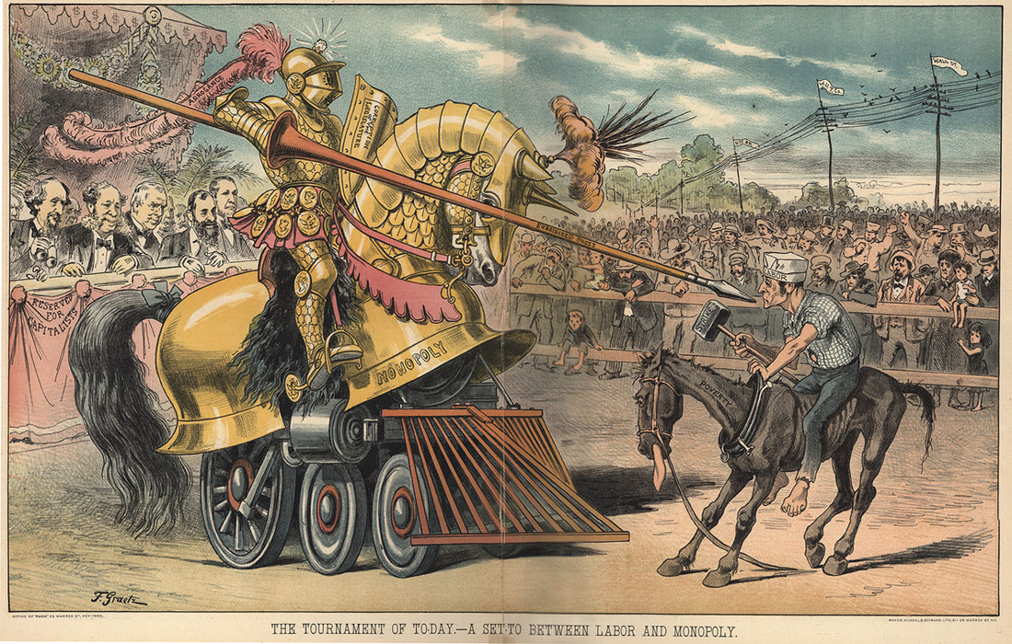

Plains Indians Wars

As the territorial boundaries of the United States expanded and the migrant population increased, U.S. government interaction and conflict with Hispanics and American Indians increased, altering these groups’ cultures and ways of life and raising questions about their status and legal rights.
- Agricultural expansion was accomplished through wars against the Plains Indians, leading to new federal Indian policies.
- The desire for access to western resources led to the environmental transformation of the region, new economic activities, and increased settlement in areas forcibly taken from American Indians.
- Post–Civil War migration to the American West, encouraged by economic opportunities and government policies, caused the federal government to violate treaties with American Indian nations in order to expand the amount of land available to settlers.
- With settlement rapidly spreading westward, Plains Indians faced the harsh choice of resistance or assimilation.
- The U.S. government generally responded to American Indian resistance with military force, eventually dispersing tribes onto small reservations and hoping to end American Indian tribal identities through assimilation.
- As transcontinental railroads were completed, bringing more settlers west, U.S. military actions, the destruction of the buffalo, the confinement of American Indians to reservations, and assimilationist policies reduced the number of American Indians and threatened native culture and identity.

“Five Civilized Tribes”
Indian Removal Act, 1830
Cherokee Nation v. Georgia, 1831
Worchester v. Georgia, 1832
Andrew Jackson
“Trail of Tears”
Indian Territory
Oklahoma Land Rush
Sooners
Plains Indians
Nomadic lifestyle
Horses
Buffalo (American bison)
Hunting & gathering
Warrior culture
Sioux
Red Cloud
Sand Creek Massacre
Col. John Chivington
“The only good Indian is a dead Indian”
Treaty of Fort Laramie, 1868
Ulysses S. Grant’s “Peace Policy”
Bureau of Indian Affairs
Indian Ring (Belknap) Scandal
William Tecumseh Sherman
Black Hills
Gold & silver mining
Railroad construction
George Armstrong Custer
Sitting Bull
Battle of Little Bighorn
Flight of the Nez Perce
Chief Joseph
Helen Hunt Jackson
A Century of Dishonor
Dawes (Severalty) Act, 1887
Assimilation policy
“Kill the Indian and save the man”
Carlisle Indian School
Disappearance of native languages
Reservations
Individual ownership of land
Sedentary agriculture
Sale of “excess” Indian land
Destruction of buffalo herds
Alcoholism
Dependence on government rations
Ration cuts as punishments
Wovoka
Ghost Dance
Wounded Knee Massacre, 1890
Dee Brown
Bury My Heart at Wounded Knee
Apache
Geronimo
Buffalo Soldiers
Buffalo Bill’s Wild West Show
Indian Citizenship Act, 1924

Settlement of the West

Western settlement offered the promise of economic opportunity but life in the west was often filled with hardship.
- Efforts to exploit the nation’s natural resources led to government efforts to promote free and forced migration of various American peoples across the continent, as well as to competing ideas about defining and managing labor systems, geographical boundaries, and natural resources.
- Asian, African American, and white peoples sought new economic opportunities or religious refuge in the West, efforts that were boosted during and after the Civil War with the passage of new legislation promoting national economic development.

Manifest Destiny
Pioneers
Self-reliance
California Gold Rush
49ers
Brigham Young
Mormon exodus
Great Salt Lake
Polygamy
Utah statehood
Comstock Lode, Nevada
59ers
Homestead Act, 1862
160 acre plots
Speculators
Morrill Land Grant Act
Sod houses
“Exodusters”
Women’s suffrage in the west
Farming, ranching & mining
Pacific Railway Act
Credit Mobilier Scandal
Transcontinental Railroad
Promontory Point, Utah
Chinese & Irish laborers
Chinese Exclusion Act
Leland Stanford
Cattle drives
Cowboys
Vaqueros
Railroads
Refrigerator car
Gustavus Swift
Meatpacking industry
Joseph Glidden
Barbed wire
Meat-packing industry
John Deere
Steel plow/“sod buster”
Cyrus McCormick
Mechanized reaper
Ecological imperialism
100th meridian
“Dry farming”
Mechanization of agriculture (“farm as a factory”)
Frederick Jackson Turner
“Frontier Thesis”
“Safety valve”

Robber Barons of the Industrial Age

During the period from the Civil War to World War I, the United States underwent an economic transformation that involved the development of an industrial economy, the expansion of big business, the growth of large-scale agriculture, and the rise of national labor unions and industrial conflict.
- Large-scale production — accompanied by massive technological change, expanding international communication networks, and pro-growth government policies — fueled the development of a “Gilded Age” marked by an emphasis on consumption, marketing, and business consolidation.
- The rise of big business in the United States encouraged massive migrations and urbanization, sparked government and popular efforts to reshape the U.S. economy and environment, and renewed debates over U.S. national identity.
- Following the Civil War, government subsidies for transportation and communication systems opened new markets in North America, while technological innovations and redesigned financial and management structures such as monopolies sought to maximize the exploitation of natural resources and a growing labor force.
- Robber barons built enormous industrial empires and wielded their power over their competitors, their employees, the federal government, and the public.
- Cultural and intellectual arguments justified the success of those at the top of the socioeconomic structure as both appropriate and inevitable, even as some leaders argued that the wealthy had some obligation to help the less fortunate.
- Business leaders consolidated corporations into trusts and holding companies and defended their resulting status and privilege through theories such as Social Darwinism.
- Large corporations came to dominate the U.S. economy as it increasingly focused on the production of consumer goods, driven by new technologies and manufacturing techniques.
- The transformation of the United States from an agricultural to an increasingly industrialized and urbanized society brought about significant economic, political, diplomatic, social, environmental, and cultural changes.
- A revolution in communications and transportation technology helped to create a new mass culture and spread “modern” values and ideas, even as cultural conflicts between groups increased under the pressure of migration, world wars, and economic distress.

First Industrial Revolution (Britain)
Second Industrial Revolution (U.S. & continental Europe)
Mark Twain
“The Gilded Age”
Robber barons
Captains of industry
Plutocracy
Navigable rivers
Textile mills
Pacific Railway Act
Land grants
Subsidies
Cornelius Vanderbilt
Transcontinental railroad
Union Pacific Railroad
Promontory Point, Utah
Southern Pacific Railroad
Leland Stanford
George Pullman
Pullman Palace Cars
Pullman, Illinois
Company towns
Time zones
Samuel F.B. Morse
Telegraph
Natural resources: coal, oil, iron, copper, bauxite (aluminum), zinc
Edwin Drake
Oil drill
John D. Rockefeller
Standard Oil Company
Andrew Carnegie
Bessemer process
Carnegie Steel Company
“The Gospel of Wealth”
J.P. Morgan
U.S. Steel
Gustavus Swift
Meatpacking industry
James B. Duke
American Tobacco Company
Thomas Edison
Light bulb
Motion picture camera
Direct current
George Westinghouse
Alternating current
“War of the currents”
Henry Ford
Assembly line
Mass production
Model T
Planned obsolescence
“$5 a day”
Workers as consumers
Wright Brothers
Airplane
Laissez-faire
Free market competition
Protective tariffs
Corporations
Limited liability
Stockholders
Wall Street
Jay Gould
“Stock watering”
J.P. Morgan
Mergers
Vertical integration
Horizontal integration
Interlocking directorates
Monopolies
Pools
Holding companies
Trusts
Munn v. Illinois, 1877
Intrastate commerce
Wabash v. Illinois, 1886
Interstate commerce
Interstate Commerce Act, 1887
Santa Clara County v. Southern Pacific Railroad, 1886
Corporate personhood
Sherman Antitrust Act, 1890
U.S. v. E.C. Knight Co., 1895
Frederick Winslow Taylor
“Scientific Management”
Unskilled/low-skill labor
Immigration
Herbert Spencer
Social Darwinism
Horatio Alger
Dime Novels
Russell Conwell
“Acres of Diamonds”
Thorstein Veblen
“Leisure class”
“Conspicuous consumption”
Newport, RI
Victorian architecture
Department stores
Mail order catalogs
Mass culture

Immigration & Urbanization

Americans and immigrants alike flocked to the cities, where jobs awaited and culture fermented.
- In the late nineteenth and early twentieth centuries, economic opportunity, industrialization, technological change, and immigration fueled American growth and expansion.
- New technologies led to social transformations that improved the standard of living for many, while contributing to increased political and cultural conflicts.
- As cities grew substantially in both size and in number, some segments of American society enjoyed lives of extravagant “conspicuous consumption,” while many others lived in relative poverty.
- The industrial workforce expanded through migration across national borders and internal migration, leading to a more diverse workforce, lower wages, and an increase in child labor.
- The emergence of an industrial culture in the United States led to both greater opportunities for, and restrictions on, immigrants, minorities, and women.
- Increased migrations from Asia and from southern and eastern Europe, as well as African American migrations within and out of the South, accompanied the mass movement of people into the nation’s cities and the rural and boomtown areas of the West.
- International and internal migrations increased both urban and rural populations, but gender, racial, ethnic, religious, and socioeconomic inequalities abounded, inspiring some reformers to attempt to address these inequities.
- Cities dramatically reflected divided social conditions among classes, races, ethnicities, and cultures, but presented economic opportunities as factories and new businesses proliferated.
- Immigrants sought both to “Americanize” and to maintain their unique identities; along with others, such as some African Americans and women, they were able to take advantage of new career opportunities even in the face of widespread social prejudices.
- Increasingly prominent racist and nativist theories, along with Supreme Court decisions such as Plessy v. Ferguson, were used to justify violence, as well as local and national policies of discrimination and segregation.
- In a urban atmosphere where the access to power was unequally distributed, political machines provided social services in exchange for political support, settlement houses helped immigrants adapt to the new language and customs, and women’s clubs and self-help groups targeted intellectual development and social and political reform.

Louis Sullivan
Skyscrapers
Elevators
John Roebling
Suspension bridges
Electric trolley
Frederick Law Olmstead
Public parks
Alexander Graham Bell
Telephone
Elias Howe & Isaac Singer
Typewriter
“Safety” bicycle
Public transportation
Trolleys/streetcars
Subways
Automobiles
Suburbs
Sewage systems
Middle class
YMCA
Spectator sports
Country clubs
Coney Island
Barnum & Bailey Circus
Buffalo Bill’s Wild West Show
James Naismith
Boxing
College football
World’s Columbian Exposition (Chicago World’s Fair)
Statue of Liberty
Emma Lazarus
“The New Colossus”
“Old immigration”: Great Britain, Germany, Ireland, Norway, and Sweden
“New immigration” from Europe: Italy, Greece, Poland, Russia, Hungary, Yugoslavia
“New immigration” from Asia: China and Japan
Melting pot vs. salad bowl
Assimilation vs. pluralism
Theodore Dreiser
Sister Carrie
Ellis Island
Angel Island
Ethnic communities
Jacob Riis
How the Other Half Lives
Jane Addams
Settlement houses
Landlords
Slums
Dumbbell tenements
Sweatshops
West Virginia & Pennsylvania coal mines
Competition for jobs
Nativism
Xenophobia
White Anglo-Saxon Protestant (WASP)
Irish immigration
Irish Potato Famine
“No Irish Need Apply” (N.I.N.A.)
“Rum, Romanism & Rebellion” (RRR)
“Anti-Papism”
German immigration
Adolphus Busch, Frederick Pabst, Joseph Schlitz, Frederick Miller
Prohibition movement
“Know-Nothings” (American Party), 1850s
Chinese immigration
Chinatowns
California Workingmen’s Party
Chinese Exclusion Act, 1882
U.S. v. Wong Kim Ark, 1898
Gentlemen’s Agreement, 1907
California Alien Land Act (Webb Alien Land Law), 1913
Little Italys
Catholicism
Jewish immigrants
Political machines
“Second” Ku Klux Klan
National Origins Quota Laws, 1920s
Jane Addams
Hull House
Settlement house movement
“Boston marriages”

Corruption & Political Paralysis

Weak presidents, partisan political machines and the spoils system made the Gilded Age a time of political graft and gridlock.
- Governmental, political, and social organizations struggled to address the effects of large-scale industrialization, economic uncertainty, and related social changes such as urbanization and mass migration.
- Corruption in government — especially as it related to big business — energized the public to demand increased popular control and reform of local, state, and national governments, ranging from minor changes to major overhauls of the capitalist system.
- Gilded Age politics were intimately tied to big business and focused nationally on economic issues — tariffs, currency, corporate expansion, and laissez-faire economic policy — that engendered numerous calls for reform.

“Gilded Age”
“Era of Good Stealings”
Patronage
Graft
Spoils system
“Straight ticket” voting
Ulysses S. Grant
“Waving the bloody shirt”
”Vote as you shot”
Veterans pensions
U.S. Postal Service
Credit Mobilier Scandal
Whisky Ring Scandal
Indian Ring (Belknap) Scandal
Horace Greely
Panic of 1873
“Hard money”
“Greenbacks”
Election of 1876
Rutherford Hayes
Compromise of 1877
“Solid South”
Disfranchisement of African Americans
James Garfield
Charles Guiteau
Civil service system
Pendleton Act, 1883
Civil service exams
Merit system
Chester A. Arthur
James G. Blaine
“Mugwumps”
Grover Cleveland
Tariff levels
Sherman Antitrust Act, 1890
Benjamin Harrison
Populist Party
Election of 1896
William Jennings Bryan
William McKinley
Political machines
Boss Tweed
Tammany Hall
George Washington Plunkitt
“Honest graft”
Thomas Nast’s political cartoons

New South or Nadir?

The South struggled to modernize, facing the dual challenges of industrialization and stagnant race relations.
- Despite the industrialization of some segments of the southern economy, a change promoted by southern leaders who called for a “New South,” agrarian sharecropping, and tenant farming systems continued to dominate the region.
- Although citizenship, equal protection of the laws, and voting rights were granted to African Americans in the 14th and 15th Amendments, these rights were progressively stripped away through segregation, violence, Supreme Court decisions, and local political tactics.
- The Civil War Amendments established judicial principles that were stalled for many decades but eventually became the basis for court decisions upholding civil rights.
- Increasingly prominent racist and nativist theories, along with Supreme Court decisions such as Plessy v. Ferguson, were used to justify violence, as well as local and national policies of discrimination and segregation.
- Discrimination against and segregation of African Americans intensified and took new forms in the late nineteenth century and early twentieth century. African Americans disagreed about how to respond to these developments.
- Challenging their prescribed “place,” African American activists articulated alternative visions of political, social, and economic equality.

Henry Woodfin Grady
Good Roads Movement
Public education
Birmingham steel industry
Southern textile industry
Piedmont vs. Tidewater
Company towns
Cheap labor
13th, 14th & 15th Amendments
Ellison Alger Smyth
Red Shirts
Lynchings
Poll tax
Grandfather clause
Literacy test
Sharecropping
Tenant farming
Debt peonage
Colored Farmers Alliance
“Jim Crow”
Racial segregation
Plessy v. Ferguson, 1896
“Equal protection under the law”
“Separate but equal”
Minstrel shows
D.W. Griffith
The Birth of a Nation
“Second” Ku Klux Klan
Convict labor
George Washington Carver
Peanuts
Booker T. Washington
“Atlanta Compromise” Speech
“Cast down your bucket where you are”
Tuskegee Institute
Vocational education
Economic self-sufficiency
Gradualism
Accommodation
W.E.B. DuBois
Niagara Movement
National Association for the Advancement of Colored People (NAACP)
“Talented Tenth”
Higher education
The Souls of Black Folk
Civil rights
Integration
Great Migration
Ida B. Wells-Barnett
Anti-lynching laws
National Association of Colored Women (NACW)

Gilded Age Arts

The “Gilded Age” witnessed new cultural and intellectual movements in tandem with political debates over economic and social policies.
- New cultural and intellectual movements both buttressed and challenged the social order of the Gilded Age.

Mark Twain
The Gilded Age
The Adventures of Tom Sawyer
The Adventures of Huckleberry Finn
Helen Hunt Jackson
A Century of Dishonor
Andrew Carnegie
“The Gospel of Wealth”
Horatio Alger
Dime novels
Russell Conwell
“Acres of Diamonds”
Thorstein Veblen
“Leisure class”
“Conspicuous consumption”
Jacob Riis
How the Other Half Lives
Walt Whitman
Leaves of Grass
Stephen Crane
The Red Badge of Courage
Maggie, Girl of the Streets
Edward Bellamy
Looking Backward
John Singer Sargent
James McNeil Whistler
Mary Cassatt
Winslow Homer
Ashcan School of Artists
Victorian architecture
Louis Sullivan
W.E.B. DuBois
The Souls of Black Folk
D.W. Griffith
The Birth of a Nation

Unit Review: Essential Questions

- What motivated the United States to exert control over Native American lands in the west?
- How did federal government policies affect the lives of Native Americans in the 19th century?
- What were the various motivations of different groups of settlers in the west?
- How did new inventions and innovations impact the economy of the west?
- How did settlers respond to and transform the environment of the west?
- How did new inventions and innovations encourage industrial growth?
- How did industrial leaders amass and wield power?
- What was the role of the federal government in encouraging the growth and regulating the practices of big business?
- What were the various governmental and social reactions to the influx of immigrants?
- To what extent did immigrants retain their traditions, assimilate, and transform American culture itself?
- Why was the period of the late 1800s nicknamed the "Gilded Age" and the "Era of Good Stealings"?
- What factors led to the development and reform of political machines and the spoils system?
- Why did meaningful reform prove difficult to accomplish during the Gilded Age?
- How was the southern economy transformed in the decades following the Civil War?
- How and why were African Americans denied the full rights guaranteed to them under the post-Civil War amendments?
- How did African American leaders respond to the challenges of racial discrimination?
- How did new cultural and intellectual movements both buttress and challenge the social order of the Gilded Age?

