APUSH Unit 8
Populism & Progressivism
APUSH 6.1 – APUSH 6.3
VUS.8d

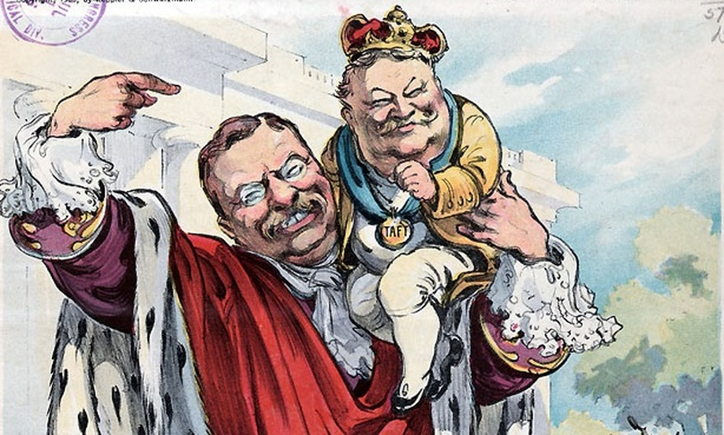

The Labor Movement

Labor and management battled for control over wages and working conditions, with workers organizing local and national unions and directly confronting corporate power.
- As cities grew substantially in both size and in number, some segments of American society enjoyed lives of extravagant “conspicuous consumption,” while many others lived in relative poverty.
- Large corporations came to dominate the U.S. economy as it increasingly focused on the production of consumer goods, driven by new technologies and manufacturing techniques.
- The industrial workforce expanded through migration across national borders and internal migration, leading to a more diverse workforce, lower wages, and an increase in child labor.
- Racism and nativism often weakened the effectiveness of the labor movement.
- Corporations and the federal government were usually hostile to organized labor and often used force to crush strikes. As a result, organized labor met with only limited success.

Labor Goals & Tactics
Wages, hours & working conditions
“Eight-hour day” movement
Skilled workers vs. unskilled workers
Craft unions vs. trade unions
Nativism
Chinese Exclusion Act, 1882
Abolition of child labor
Strike
Wildcat strike
Collective bargaining
Closed shop
Mediation & arbitration

Management Goals & Tactics
Yellow dog contract
Lockout
“Scabs”
Pinkertons
Blacklist
Sherman Antitrust Act injunctions against labor unions
Open shop

Organizations, Leaders & Events
National Labor Union
Knights of Labor
Terence V. Powderly
Mother Jones
President Rutherford B. Hayes
Great Railroad Strike, 1877
Haymarket Square Riot (Haymarket Affair), 1886
American Federation of Labor
Samuel Gompers
Carnegie Steel Company
Homestead Strike, 1892
Coxey’s Army, 1894
Company towns
Debt peonage
Pullman, Illinois
President Grover Cleveland
Pullman Strike, 1894
President Theodore Roosevelt
United Mine Workers (UMW)
Anthracite Coal Strike, 1902
International Ladies’ Garment Workers Union (ILGWU)
Florence Kelly
Triangle Shirtwaist Fire, 1911
Ludlow Massacre, 1914

Radical Labor
Karl Marx & Friedrich Engels
The Communist Manifesto, 1848
Edward Bellamy
Looking Backward, 1888
Utopian socialism
Socialist Party
Eugene Debs’ presidential campaigns, 1900-1920
Jack London
The Iron Heel
Industrial Workers of the World (IWW/“Wobblies”)
“One Big Union”

Rise and Fall of Populism

The growth of corporate power in agriculture and economic instability in the farming sector inspired activists to create the People’s (Populist) Party, which called for political reform and a stronger governmental role in the American economic system.
- Farmers adapted to the new realities of mechanized agriculture and dependence on the evolving railroad system by creating local and regional organizations that sought to resist corporate control of agricultural markets.
- Western farmers fought largely in vain against the transformation of American agriculture and the larger economy.
- Many of the ideas proposed by the rural Populist movement were later adopted and successfully implemented by the urban Progressive movement.

Mechanization of agriculture/ “farm as a factory”
Debt
Deflation
Drought
Locusts
Trusts
Tariffs
Railroad rates
Oliver Kelley
The Grange (Patrons of Husbandry)
Social gatherings
Cooperatives
Greenbacks
Greenback Labor Party
Granger laws (regulation of railroads)
Munn v. Illinois, 1877
Intrastate commerce
Wabash v. Illinois, 1886
Interstate commerce
Interstate Commerce Act, 1887
Sherman Antitrust Act, 1890
U.S. v. E.C. Knight Co., 1895
Interstate Commerce Commission
Farmers’ Alliances: Northern, Southern, Colored
Mary Elizabeth Lease
James B. Weaver
Coxey Armies
Populist (People’s) Party
Election of 1892
James B. Weaver
Omaha Platform, 1892
Abolition of the national bank
Direct democracy
Direct election of senators
Australian (secret) ballot
Government ownership (nationalization) of railroads
Nativism
8-hour workday
Gold, silver & bimetallism
Panic of 1893
Election of 1896
William Jennings Bryan
“Cross of Gold” Speech
“Gold bugs” vs. “silverites”
William McKinley
Marcus Hanna
Campaign finance
Dingley Tariff, 1897
Gold Standard Act, 1900
L. Frank Baum
The Wonderful Wizard of Oz
Frank Norris
The Octopus, 1901

The Progressive Movement

The Progressive movement achieved sweeping reforms that improved the lives of workers, consumers, women, children and made government more democratic.
- In the late 1890s and the early years of the 20th century, journalists and Progressive reformers — largely urban and middle class, and often female — worked to reform existing social and political institutions at the local, state, and federal levels by creating new organizations aimed at addressing social problems associated with an industrial society.
- Progressive reformers responded to economic instability, social inequality, and political corruption by calling for government intervention in the economy, expanded democracy, greater social justice, and conservation of natural resources.
- Business interests battled conservationists as the latter sought to protect sections of unspoiled wilderness through the establishment of national parks and other conservationist and preservationist measures.
- The women’s rights movement was both emboldened and divided over the 14th and 15th Amendments to the Constitution. Challenging their prescribed “place,” women activists articulated alternative visions of political, social, and economic equality.
- Corruption in government — especially as it related to big business — energized the public to demand increased popular control and reform of local, state, and national governments, ranging from minor changes to major overhauls of the capitalist system.
- A number of critics challenged the dominant corporate ethic in the United States and sometimes capitalism itself, offering alternate visions of the good society through utopianism and the Social Gospel.

Progressivism
Robert “Fighting Bob” LaFollette
“Wisconsin Idea”
Academic-public alliance
Henry James
Pragmatism
John Dewey
“Learning by doing”
Normal schools
Chautauqua movement
“Social Gospel” (Liberal Protestantism)
Middle class
Direct democracy
Initiative
Referendum
Recall
City managers & commissioners
Australian (secret) ballot
Primary elections (direct primaries)
17th Amendment
Muckrakers
Frank Norris
The Octopus
Lincoln Steffens
The Shame of the Cities
Jacob Riis
How the Other Half Lives
Jane Addams
Hull House
Settlement houses
Henry Demarest Lloyd
Ida Tarbell
The History of Standard Oil
Monopolies & trusts
Enforcement of the Sherman Antitrust Act (“trust-busting”)
Upton Sinclair
The Jungle
Consumer protection
Meat Inspection Act/Pure Food & Drug Act
John Spargo
The Bitter Cry of the Children
Child labor
Lochner v. New York, 1905
Loewe v. Lawlor (Danbury Hatters case), 1908
Muller v. Oregon, 1908
“Maternal welfare”
International Ladies Garment Workers Union (ILGWU)
Florence Kelly
Triangle Shirtwaist Fire
Labor departments
Minimum wage laws
Workers compensation
Industrial Workers of the World (IWW/“Wobblies”)
Socialist Party
Eugene Debs
Carrie Nation
Women’s Christian Temperance Union (WCTU)
18th Amendment
Volstead Act
Prohibition
Victorian morality
Comstock Law of 1873
Kate Chopin
The Awakening
Victoria Woodhull
“Free love”
Divorce rates
Family size
Birth control
Sterilization programs
Women’s suffrage in the west
Susan B. Anthony
Civil disobedience
Carrie Chapman Catt
National American Women’s Suffrage Association (NAWSA)
Alice Paul
National Women’s Party (NWP)
Women in factories during World War I
19th Amendment
League of Women Voters
Sierra Club
Audubon Society
Frederick Law Olmstead
City parks
Conservation
John Muir
Land management
Gifford Pinchot
National parks

Progressive Presidents

Presidents Theodore Roosevelt, William Taft and Woodrow Wilson responded to the progressive movement by increasing the role of the federal government in regulating the economy.

Theodore Roosevelt Administration
Assassination of William McKinley
Anthracite Coal Strike
United Mine Workers
Arbitration
“Square Deal”
Northern Securities v. U.S., 1904
Enforcement of the Sherman Antitrust Act (“trust-busting”)
“Good trusts” vs. “bad trusts”
“Big Stick”
“Bully pulpit”
Meat Inspection Act
Pure Food & Drug Act
Elkins Act
Railroad rebates
Hepburn Act
Free passes
Interstate Commerce Commission
Booker T. Washington
Conservation
John Muir
Land management
Gifford Pinchot
Sierra Club
Newlands Reclamation Act
National Parks

William H. Taft Administration
Mann-Elkins Act
Payne-Aldrich Tariff
Ballinger-Pinchot Affair
U.S. v. U.S. Steel
16th Amendment
Income tax

Election of 1912
Theodore Roosevelt
“New Nationalism”
Progressive (Bull Moose) Party
William H. Taft
Republican Party
Woodrow Wilson
Democratic Party
“New Freedom”
Eugene Debs
Socialist Party
Eugene Chafin
Prohibition Party

Woodrow Wilson Administration
World War I
Underwood Tariff
Tariff reductions
Graduated (progressive) income tax
Federal Reserve Act
Discount (interest) rate
Federal Trade Commission (FTC)
Clayton Antitrust Act
Child Labor Laws
Adamson Act
17th Amendment
Direct election of senators
18th Amendment
Prohibition of alcohol
19th Amendment
Women’s suffrage

Unit Review: Essential Questions
- How successful were labor unions in improving the lives of workers in the late 1800s and early 1900s?
- How did states and the federal government respond to the labor movement?
- What factors contributed to the rise of the farmers’ movement?
- To what extent did the Populist movement achieve its goals?
- How did the excesses of the Gilded Age contribute to the development of the Progressive Movement?
- How did women influence the direction of the Progressive movement?
- How did the Progressive movement achieve political, economic, social and environmental reform?
- How did the Progressive movement affect national electoral politics?

