“Robber Barons” or “Captains of Industry”?
 | 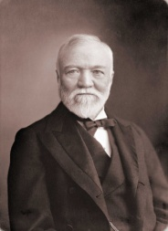  Andrew Carnegie | 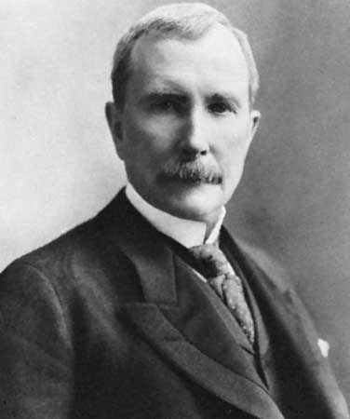  John D Rockefeller | 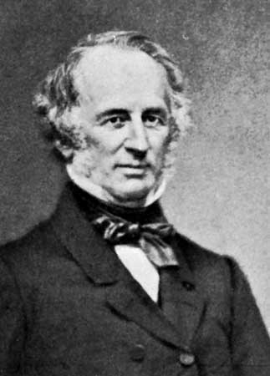  Cornelius Vanderbilt | 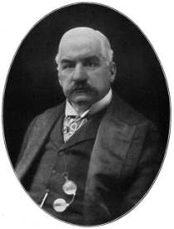  JP  Morgan
How did he acquire wealth? (business practices) | Dominated the steel industry… Carnegie Steel  Bessemer process | Oil refineries… Standard Oil monopoly/trust  Glue & paint from by-products of oil industry  Built pipelines & RRs to control transportation of his oil & bought other companies | Railroads & steamships… transportation  Ran competitors out of business by slashing prices, pressured Nicaraguan gov’t to build RR | Banking & stock trading/finance  Later bought Carnegie Steel… became US Steel
How did he treat his workers? (labor strife) | Slashed wages… Homestead Strike… hired Pinkertons to use violence against strikers, hired scabs, crushed the union | ??? | Great RR Strike of 1877 | ???
How did he spend his wealth? (conspicuous consumption) | European vacations, mansions | ??? | Steam yacht, vacations in Europe, built Grand Central Station in NYC | Yacht races – America’s cup, huge art collection
How did he donate his wealth? (philanthropy) | Music hall (Carnegie Hall), educational grants, 3000 public libraries, Carnegie-Mellon University | Medical & public health | Kept $99 million for himself; donated $50,000 to church and $1 million to “Vanderbilt” University | Built NYC Metropolitan Club for NY millionaires; donated art to NY Metropolitan Museum (“The Met”); books to Morgan Library of NY, Harvard Med School & Duke Univ.
“Robber Baron” or “Captain of Industry”? Why? | Both! | Captain b/c he gave back later in life | Robber baron b/c he kept most of his money | Captain b/c he used money & power to help US out of a “panic”
“Robber Barons” or “Captains of Industry”?
 | Andrew Carnegie | John D Rockefeller | Cornelius Vanderbilt | JP  Morgan
How did he acquire wealth?
How did he treat his workers?
How did he spend his wealth?
How did he donate his wealth?
“Robber Baron” or “Captain of Industry”? Why?

