Timeline of Watergate & Related Scandals

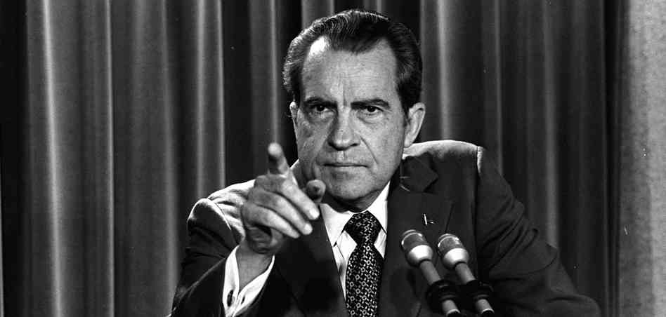

1968
- November 1968: Richard Milhous Nixon, the 55-year-old former vice president who lost the presidency for the Republicans in 1960, reclaims it by defeating Hubert Humphrey in one of the closest elections in U.S. history.
1970
- July 23, 1970: Nixon approves a plan for greatly expanding domestic intelligence-gathering by the FBI, CIA and other agencies. He has second thoughts a few days later and rescinds his approval.
1971
- March 8, 1971: A group calling itself the “Citizens Committee to Investigate the FBI” breaks into the FBI field office in Media, Pennsylvania. The documents they steal reveal the existence of the FBI’s Counterintelligence Program (COINTELPRO), an operation which had surveilled and attempted to discredit suspected communists as well as civil rights and antiwar leaders.
- June 13, 1971: The New York Times begins publishing the Pentagon Papers – the Defense Department’s secret history of the Vietnam War. The Washington Post will begin publishing the papers later in the week.
- September 9, 1971: The White House “plumbers” unit – named for their orders to plug leaks in the administration – burglarizes a psychiatrist’s office to find files on Daniel Ellsberg, the former defense analyst who leaked the Pentagon Papers.
1972
- June 17, 1972: Five men, one of whom says he used to work for the CIA, are arrested at 2:30 a.m. trying to bug the offices of the Democratic National Committee at the Watergate hotel and office complex.
- June 19, 1972: A GOP security aide is among the Watergate burglars, The Washington Post reports. Former attorney general John Mitchell, head of the Nixon reelection campaign, denies any link to the operation.
- August 1, 1972: A $25,000 cashier’s check, apparently earmarked for the Nixon campaign, wound up in the bank account of a Watergate burglar, The Washington Post reports.
- September 29, 1972: John Mitchell, while serving as attorney general, controlled a secret Republican fund used to finance widespread intelligence-gathering operations against the Democrats, The Post reports.
- October 10, 1972: FBI agents establish that the Watergate break-in stems from a massive campaign of political spying and sabotage conducted on behalf of the Nixon reelection effort, The Post reports.
- November 11, 1972: Nixon is reelected in one of the largest landslides in American political history, taking more than 60 percent of the vote and crushing the Democratic nominee, Sen. George McGovern of South Dakota.
1973
- January 30, 1973: Former Nixon aides G. Gordon Liddy and James W. McCord Jr. are convicted of conspiracy, burglary and wiretapping in the Watergate incident. Five other men plead guilty, but mysteries remain.
- April 30, 1973: Nixon’s top White House staffers, H.R. Haldeman and John Ehrlichman, and Attorney General Richard Kleindienst resign over the scandal. White House counsel John Dean is fired.
- May 18, 1973: The Senate Watergate committee begins its nationally televised hearings. Attorney General-designate Elliot Richardson taps former solicitor general Archibald Cox as the Justice Department’s special prosecutor for Watergate.
- June 3, 1973: John Dean has told Watergate investigators that he discussed the Watergate cover-up with President Nixon at least 35 times, The Post reports.
- June 13, 1973: Watergate prosecutors find a memo addressed to John Ehrlichman describing in detail the plans to burglarize the office of Pentagon Papers defendant Daniel Ellsberg’s psychiatrist, The Post reports.
- July 13, 1973: Alexander Butterfield, former presidential appointments secretary, reveals in congressional testimony that since 1971 Nixon had recorded all conversations and telephone calls in his offices.
- July 18, 1973: Nixon reportedly orders the White House taping system disconnected.
- July 23, 1973: Nixon refuses to turn over the presidential tape recordings to the Senate Watergate committee or the special prosecutor.
- October 10, 1973: Vice President Spiro Agnew is forced to resign as evidence mounts that he is guilty of income tax evasion. Gerald Ford will eventually replace him as vice president.
- October 20, 1973: “Saturday Night Massacre”: Nixon fires Archibald Cox and abolishes the office of the special prosecutor. Attorney General Richardson and Deputy Attorney General William D. Ruckelshaus resign. Pressure for impeachment mounts in Congress.
- November 17, 1973: Nixon declares, “I’m not a crook,” maintaining his innocence in the Watergate case.
- December 7, 1973: The White House can’t explain an 18 ½-minute gap in one of the subpoenaed tapes. Chief of staff Alexander Haig says one theory is that “some sinister force” erased the segment.
1974
- April 30, 1974: The White House releases more than 1,200 pages of edited transcripts of the Nixon tapes to the House Judiciary Committee, but the committee insists that the tapes themselves must be turned over.
- July 24, 1974: The Supreme Court rules unanimously in the case of U.S. v. Nixon that Nixon must turn over the tape recordings of 64 White House conversations, rejecting the president’s claims of executive privilege.
- July 27, 1974: House Judiciary Committee passes the first of three articles of impeachment, charging obstruction of justice.
- August 8, 1974: Richard Nixon becomes the first U.S. president to resign. Vice President Gerald R. Ford assumes the country’s highest office. He will later pardon Nixon of all charges related to the Watergate case.
1975
- The Senate’s Church Committee begins its investigation into the CIA, FBI and NSA’s domestic and international spying activities. The committee recommends greater Congressional oversight over intelligence operations.

Source: http://watergate.info/chronology/brief-timeline-of-events

