APUSH Unit 10
Prosperity, Depression
& New Deal
APUSH 7.1 – APUSH 7.2
VUS.10a – VUS.10d

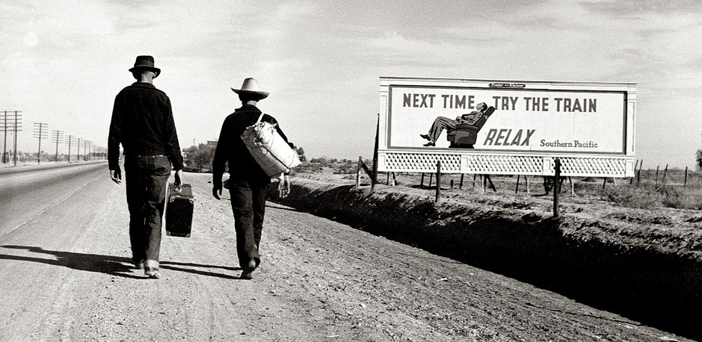

Society in the Roaring Twenties

Changes in race relations, gender roles, religious beliefs and technology made the 1920s a dynamic decade.
- A revolution in communications and transportation technology helped to create a new mass culture and spread “modern” values and ideas, even as cultural conflicts between groups increased under the pressure of migration, world wars, and economic distress.
- New technologies led to social transformations that improved the standard of living for many, while contributing to increased political and cultural conflicts.
- New technologies contributed to improved standards of living, greater personal mobility, and better communications systems.
- Technological change, modernization, and changing demographics led to increased political and cultural conflict on several fronts: tradition versus innovation, urban versus rural, fundamentalist Christianity versus scientific modernism, management versus labor, native-born versus new immigrants, white versus black, and idealism versus disillusionment.
- The rise of an urban, industrial society encouraged the development of a variety of cultural expressions for migrant, regional, and African American artists (expressed most notably in the Harlem Renaissance movement); it also contributed to national culture by making shared experiences more possible through art, cinema, and the mass media.

Jazz Age
18th Amendment
Volstead Act
Prohibition
Bootleggers
Al Capone
Automobiles
Radio
Advertising & marketing
Fads
Silent films & talkies
Mass culture
Charles Lindberg
Sigmund Freud
Psychoanalysis
Margaret Sanger
Birth control
Flappers
Lost Generation
F. Scott Fitzgerald
The Great Gatsby
Ernest Hemingway
Sinclair Lewis
Babbitt
Armory Exhibition of 1913
Modernism
Ezra Pound
Functionalism
Frank Lloyd Wright
Edward Hopper
Georgia O’Keefe
Art Deco
Harlem Renaissance
Countee Cullen
Langston Hughes
James Weldon Johnson
Claude McKay
Louis Armstrong
Duke Ellington
Bessie Smith
Paul Robeson
Marcus Garvey
Fundamentalism
Billy Sunday
Aimee Semple McPherson
Scopes Trial
Clarence Darrow
William Jennings Bryan
Red Scare
Sacco & Vanzetti
Ku Klux Klan
Immigration Quota Acts

Republican Politics of the 1920s

Presidents Harding, Coolidge and Hoover supported policies that encouraged the rapid expansion of the American economy in the Twenties.

Warren G. Harding
“Return to Normalcy”
Laissez-faire
Welfare capitalism vs. “Welfare for capitalism”
Revenue Act of 1921
Andrew Mellon
Fordney-McCumber Tariff
Protectionism
Spoils system
Teapot Dome Scandal
Albert Fall
Washington Naval Conference/Five Power Treaty
Dawes Plan
Calvin Coolidge
“The business of America is business”
Revenue Act of 1924
Indian Citizenship Act of 1924
Kellogg-Briand Pact
Election of 1928
Herbert Hoover
Al Smith
Catholicism
“Wet” vs. “dry” politicians
Tammany Hall

The Great Depression

The 1929 Stock Market Crash marked the beginning of the Great Depression.
- Even as economic growth continued, episodes of credit and market instability, most critically the Great Depression, led to calls for the creation of a stronger financial regulatory system.
- National, state, and local reformers responded to economic upheavals, laissez-faire capitalism, and the Great Depression by transforming the U.S. into a limited welfare state.

Stock market
Wall Street
Dow Jones Index
Easy credit
Protective tariffs
Overproduction
Speculation
Buying on margin
Unequal distribution of wealth
Declining demand for American agricultural products
Black Tuesday
Great Depression
Bankruptcies
Unemployment
“Runs on the bank” & bank failures
Tight credit
Rugged individualism
Voluntary action
Protectionism
Hawley-Smoot Tariff of 1929
Farm Board
Reconstruction Finance Corporation (RFC)
Debt moratorium
Bonus March
Homelessness
“Hoovervilles”
Hobos
Decline in consumer demand
Farm foreclosures
Dust Bowl
Okies
John Steinbeck
Of Mice and Men
The Grapes of Wrath

FDR’s New Deal: Alphabet Soup

Franklin Roosevelt’s response to the Great Depression greatly expanded the role of the federal government in regulating the economy.
- The liberalism of President Franklin Roosevelt’s New Deal drew on earlier progressive ideas and represented a multifaceted approach to both the causes and effects of the Great Depression, using government power to provide relief to the poor, stimulate recovery, and reform the American economy.
- Radical, union, and populist movements pushed Roosevelt toward more extensive reforms, even as conservatives in Congress and the Supreme Court sought to limit the New Deal’s scope.
- Although the New Deal did not completely overcome the Depression, it left a legacy of reforms and agencies that endeavored to make society and individuals more secure, and it helped foster a long-term political realignment in which many ethnic groups, African Americans, and working-class communities identified with the Democratic Party.

Election of 1932
Franklin D. Roosevelt
Eleanor Roosevelt
20th Amendment
FDR’s First Inaugural Address (“The only thing we have to fear is fear itself”)
First New Deal
Second New Deal
Relief, recovery, reform
Welfare state
Brain trust
The “Hundred Days”
Fireside chats
Emergency Banking Act
(Bank holiday)
Glass-Steagall Act
Federal Deposit Insurance Corporation (FDIC)
Abandonment of gold standard
Tariff reductions
Securities & Exchange Commission (SEC)
21st Amendment
“Alphabet soup”
Public Works Administration (PWA)
Civilian Conservation Corps (CCC)
Tennessee Valley Authority (TVA)
National Industrial Recovery Act (NIRA)/National Recovery Administration (NRA)
Wage controls
Price controls
Partial employment
Schecter Poultry v. U.S., 1935
Agricultural Adjustment Administration (AAA)
Rexford Tugwell
Farm subsidies
Artificial scarcity
Redistribution of wealth
Butler v. U.S., 1936
Farm Security Administration (FSA)
Resettlement Administration (RA)
Bonus Bill
Works Progress Administration (WPA)
Harry Hopkins
Federal Theater Project (FTP)
“Talking newspapers”
Federal Housing Administration (FHA)
Francis Townshend
Social Security Administration (SSA)
Deficit spending
John Maynard Keynes
National debt
Demagogues
Populism
Huey Long
“Share Our Wealth”
Father Charles Coughlin
“Creeping socialism”
Court packing scandal
Recession of 1937
Election of 1940
Wendell Willkie
World War II

FDR’s New Deal: Labor & Race Relations

Franklin Roosevelt’s New Deal offered strong protections for labor but had a mixed record on civil rights.
- Economic dislocations, social pressures, and the economic growth spurred by World Wars I and II led to a greater degree of migration within the United States, as well as migration to the United States from elsewhere in the Western Hemisphere.
- Although most African Americans remained in the South despite legalized segregation and racial violence, some began a “Great Migration” out of the South to pursue new economic opportunities offered by World War I.
- Many Americans migrated during the Great Depression, often driven by economic difficulties, and during World Wars I and II, as a result of the need for wartime production labor.
- Many Mexicans, drawn to the U.S. by economic opportunities, faced ambivalent government policies in the 1930s and 1940s.

Frances Perkins
Wagner Act
National Labor Relations Board (NLRB)
Fair Labor Standards Act (FLSA)
Minimum wage
Living wage
Congress of Industrial Organizers (CIO)
United Mine Workers (UMW)
John Lewis
Flint GM sit-down strike
United Auto Workers (UAW)
Second Bill of Rights (Economic Bill of Rights)
Racial segregation
New Deal Democratic Coalition
A. Philip Randolph
March on Washington movement
Executive Order 8802
Marian Anderson
Black Cabinet
Indian New Deal/Indian Reorganization Act/ “Termination” policy
John Collier
Bracero program
Executive Order 9066
Korematsu v. U.S.
Attack on Pearl Harbor
World War II
Full employment
Rosie the Riveter
22nd Amendment

Unit Review: Essential Questions

- How did the 1920s expose tensions between new and changing attitudes on the one hand and traditional values and nostalgia on the other?
- To what extent did Republican economic policies of the 1920s contrast with the progressive policies of the 1900s and 1910s?
- What caused the stock market crash of 1929?
- What were consequences of the stock market crash of 1929?
- How did the New Deal attempt to address the causes and effects of the Great Depression?
- What impact did the New Deal have on the role of the federal government?
- How effective was the New Deal in advancing labor rights and civil rights?

