APUSH Unit 11
World War II
APUSH 7.2 – APUSH 7.3
VUS11.a – VUS.12d

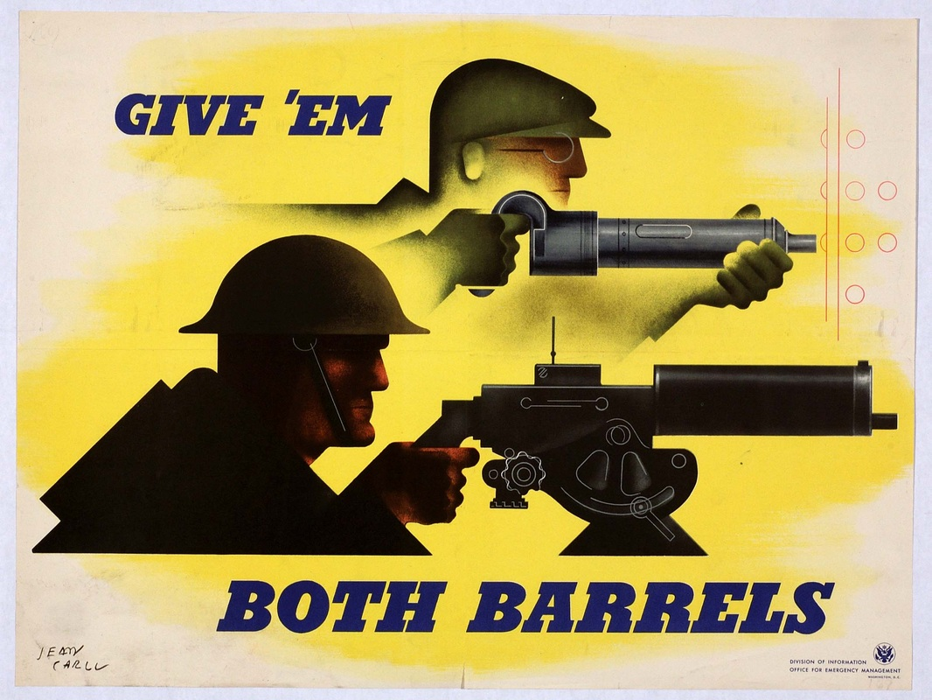

World War II Begins

Totalitarianism and military aggression endangered international peace in the 1930s as western democracies failed to prevent the outbreak of World War II.

Soviet Union
Joseph Stalin
Communism
Japan
Emperor Hirohito
Hideki Tojo
Occupation of Korea & Manchuria
Sino-Japanese War, 1937-1945
Italy
Benito Mussolini
Fascism
Invasion of Ethiopia, 1935
Spanish Civil War
Francisco Franco
Germany
Treaty of Versailles
Great Depression
Hyperinflation
Adolf Hitler
Nazism
“Anschluss” with Austria, 1938
Munich Pact, 1938
Appeasement
German invasion of Poland, 1939
“Blitzkrieg”
Soviet invasion of Poland & Baltic states, 1939
Winter War, 1939-1940
Invasion of France, 1940
Battle of Britain (The “Blitz”), 1940
Radar
Invasion of the Soviet Union, 1941
Soviet & Middle Eastern oil fields
Axis Powers
Allied Powers

U.S. Foreign Policy Before Pearl Harbor

The United States largely sought to remain neutral and isolated from international conflicts in the 1920s and 1930s, but was gradually pulled into World War II.

Neutrality
Isolationism
League of Nations
Reservationists & Irreconcilables
Dawes Plan
Kellogg-Briand Pact
Great Depression
Hawley-Smoot Tariff
Franklin D. Roosevelt
American Neutrality Acts
Good Neighbor Policy
London Economic Conference
Reciprocal trade
Recognition of the Soviet Union
Abraham Lincoln Brigade
Quarantine Speech
Nye Committee
Charles Lindbergh
“America First” Committee
Cash & Carry
Destroyers for Bases
Election of 1940
Four Freedoms Speech
Lend-Lease Act
“Arsenal of Democracy”
Winston Churchill
Atlantic Charter
Stimson Doctrine
Tydings-McDuffie Act
Panay Incident
U.S. oil & steel embargoes against Japan
Pearl Harbor attack

The U.S. in the European Theater

U.S. forces supplied arms to Allied forces and helped to open additional battle fronts that strained German military resources.
- The United States and its allies achieved victory over the Axis powers through a combination of factors, including allied political and military cooperation, industrial production, technological and scientific advances, and popular commitment to advancing democratic ideals.
- The involvement of the United States in World War II, while opposed by most Americans prior to the attack on Pearl Harbor, vaulted the United States into global political and military prominence, and transformed both American society and the relationship between the United States and the rest of the world.

“Germany first” strategy
Battle of El Alamein, 1942
Operation Torch, 1942
Battle of the Atlantic
Convoy system
Battle of Stalingrad, 1942-1943
Allied invasion of Italy (Battle of Anzio), 1943
General Dwight D. Eisenhower
Operation Overlord (D-Day/ Invasion of Normandy), 1944
Strategic bombing
Incendiary bombing
Battle of the Bulge, 1944-1945
Battle of Berlin, 1945
V-E Day

The U.S. in the Pacific Theater

The U.S. played a decisive role in the defeat of Japan by seizing Japanese-occupied islands and using atomic bombs to bring the war in the Pacific to an end.
- The United States and its allies achieved victory over the Axis powers through a combination of factors, including allied political and military cooperation, industrial production, technological and scientific advances, and popular commitment to advancing democratic ideals.
- The involvement of the United States in World War II, while opposed by most Americans prior to the attack on Pearl Harbor, vaulted the United States into global political and military prominence, and transformed both American society and the relationship between the United States and the rest of the world.
- Wartime experiences such as the decision to drop the atomic bomb raised questions about American values.

Pearl Harbor attack
Japanese Pacific offensive of December 1941
Bataan Death March
“Island hopping” strategy
Air bases
General Douglas MacArthur
Admiral Chester Nimitz
Battle of the Coral Sea, 1942
Battle of Midway, 1942
Aircraft carriers
Battle of Guadalcanal, 1943
Battle of Leyte Gulf, 1944
Battles of Iwo Jima & Okinawa, 1944-1945
Kamikaze attacks
Incendiary bombing
Harry Truman
Potsdam Declaration
Robert Oppenheimer
Los Alamos Laboratory
Manhattan Project
Atomic bombings of Hiroshima & Nagasaki
V-J Day

Planning for Peace

Allied conferences established a post-war order shaped by human rights concerns, the formation of the United Nations peacekeeping organization and the opposing forces of the U.S. and Soviet Union.
- The involvement of the United States in World War II, while opposed by most Americans prior to the attack on Pearl Harbor, vaulted the United States into global political and military prominence, and transformed both American society and the relationship between the United States and the rest of the world.
- The dominant American role in the Allied victory and postwar peace settlements, combined with the war-ravaged condition of Asia and Europe, allowed the United States to emerge from the war as the most powerful nation on earth.

Bombing campaigns
- The “Blitz”
- Strategic & incendiary bombing
- Atomic bombs
“Rape of Nanjing”
“Comfort” women
Prisoners of war (POWs)
Bataan Death March
“Hell ships”
Gulags
POWs on the western front
Japanese-American internment
Geneva Conventions (I-IV) of 1949
Atlantic Charter
Yalta Conference
Allied division and occupation of Germany
Iron Curtain
Cold War
United States & Soviet Union as world “superpowers”
San Francisco Conference
United Nations
U.N. Security Council
Universal Declaration of Human Rights
Eleanor Roosevelt
Holocaust
Genocide
“Final Solution”
Victims of the Holocaust
- Poles
- Jews
- Slavs
- Gypsies (Roma)
- homosexuals
- handicapped
- mentally ill
- political dissidents
- POWs
Nuremburg & Tokyo Tribunals
Nuremburg Defense (“I was only following orders”)
Nuremburg Principle (individual responsibility to disobey illegal or immoral orders)
Zionism
State of Israel, 1948
American occupation of Japan
MacArthur “Peace Constitution”
Japanese “economic miracle”

The Homefront

World War II created new opportunities for many Americans, though Japanese Americans faced extreme discrimination.
- The mass mobilization of American society to supply troops for the war effort and a workforce on the home front ended the Great Depression and provided opportunities for women and minorities to improve their socioeconomic positions.
- Many Americans migrated during the Great Depression, often driven by economic difficulties, and during World Wars I and II, as a result of the need for wartime production labor.
- Many Mexicans, drawn to the U.S. by economic opportunities, faced ambivalent government policies in the 1930s and 1940s.
- Wartime experiences such as the internment of Japanese Americans, challenges to civil liberties, and debates over race and segregation raised questions about American values.

Selective Service Act of 1940
War Production Board
Office of Price Administration
Rationing
Victory (Liberty) Gardens
War Bonds
Income tax
Censorship
Propaganda & racial stereotypes
West Virginia State Board of Education v. Barnette, 1943
Full employment
National War Labor Board
Rosie the Riveter
Women’s Army Corps (WACs)
African Americans in segregated units
Buffalo Soldiers
Tuskegee Airmen
Great Migration
A. Philip Randolph
March on Washington movement
Double-V Campaign
Executive Order 8802
Zoot Suit Riots
Mexican-American soldiers in integrated units
Bracero Program
Navajo Codetalkers
Executive Order 9066
Japanese-American internment
Korematsu v. U.S., 1944
Nisei Regiments
Servicemen’s Readjustment Act (G.I. Bill)
Fair Deal
Levittowns
Suburban sprawl
Middle class
Baby boom

Unit Review: Essential Questions

- How and why did the U.S. become increasingly involved in World War II?
- What role did the United States play in the Allied victory in World War II?
- How did a concern for human rights and global security shape the post-war world?
- To what extent did the homefront experience during World War II expand the freedoms and opportunities available to Americans?

