APUSH Unit 6
Civil War & Reconstruction
APUSH 5.2 – APUSH 5.3
VUS.7a – VUS.7f

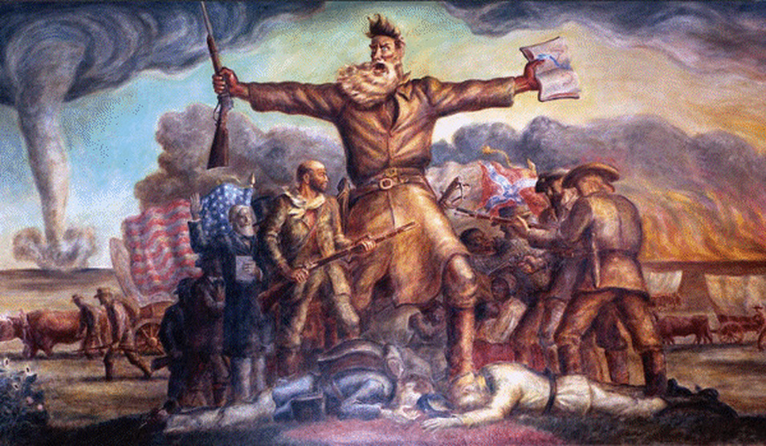

Debating Slavery & Secession

Mounting sectional tensions and a failure of political will led to the Civil War. Lincoln’s election on a free soil platform in the election of 1860 led various Southern leaders to conclude that their states must secede from the Union.

Missouri Compromise (of 1820)
Balance of power in congress
Tariffs
National bank
Abolition movement
Expansion of slavery
Fugitive slaves
Southern arguments in defense of slavery
Compromise of 1850
Harriet Beecher Stowe
Uncle Tom’s Cabin
Free Soil Party
“Bleeding Kansas”
Republican Party
Dred Scott v. Sanford, 1857
James Buchanan
Lincoln-Douglas Debates, 1858
John Brown’s raid at Harpers Ferry, 1859
Southern militia system
Election of 1860
Nationalism
Unionism
Sectionalism
States’ rights
10th Amendment
Confederation
Collection of “sovereign states”
Secession
Rebellion/insurrection
South Carolina Declaration of Causes, 1860
U.S.A./Union/North/Yankees/ Federals
Abraham Lincoln
Andrew Johnson
C.S.A./Confederacy/South/ Rebels/“Secesh”
Jefferson Davis
Alexander Stephens
West Virginia
Border States
Crittenden Compromise
Lincoln’s First Inaugural Address
Attack on Fort Sumter, 1861
Lincoln’s call for federal troops

Turning Points of the Civil War

Although Confederate leadership showed initiative and daring early in the war, the Union ultimately succeeded due to improved military leadership, more effective strategies, key victories, greater resources, and the wartime destruction of the South’s environment and infrastructure.
- The secession of Southern states triggered a long and costly war that concluded with Northern victory and resulted in the restoration of the Union and emancipation of the slaves.
- The North’s greater manpower and industrial resources, its leadership, and the decision for emancipation eventually led to the Union military victory over the Confederacy in the devastating Civil War.
- Lincoln’s decision to issue the Emancipation Proclamation changed the purpose of the war, enabling many African Americans to fight in the Union Army, and helping prevent the Confederacy from gaining full diplomatic support from European powers.
- The Civil War put constitutional government to its most important test as the debate over the power of the federal government versus states’ rights reached a climax. The survival of the United States as one nation was at risk, and the nation’s ability to bring to reality the ideals of liberty, equality, and justice depended on the outcome of the war.
- Lincoln’s Gettysburg Address said the United States was one nation, not a federation of independent states. For Lincoln, the Civil War was about preserving the Union as a nation “of the people, by the people, and for the people.”
- Lincoln believed the Civil War was fought to fulfill the promise of the Declaration of Independence and was a “Second American Revolution.” He described a different vision for the United States from the one that had prevailed from the beginning of the Republic to the Civil War.

Anaconda Plan
War of attrition
Minié ball & repeating rifle
First Battle of Bull Run/Manassas, 1861
Stonewall Jackson
Robert E. Lee
George McClellan
Peninsula Campaign, 1862
David Farragut
Ironclads
Monitor & Merrimack
Battle of Hampton Roads, 1862
Battle of Antietam, 1862
Emancipation Proclamation
Ulysses S. Grant
Siege of Vicksburg, 1863
Battle of Gettysburg, 1863
Gettysburg Address, 1863
“Four score and seven years ago…”
Declaration of Independence’s claim that “all men are created equal”
“Last full measure of devotion”
“New birth of freedom”
“Government of the people, by the people, for the people”
Proclamation of Thanksgiving
Peace Democrats
George McClellan
“Copperheads”
Clement Vallandingham
William Tecumseh Sherman
Sherman’s March, 1864
“Scorched earth” & “total war”
War Democrats
National Union Party
Election of 1864
Richmond-Petersburg Campaign, 1864-1865
Appomattox Courthouse, 1865
The “Lost Cause”
Assassination of Abraham Lincoln
John Wilkes Booth
Walt Whitman
“O Captain, My Captain”

Civil War Diplomacy & The Homefront

Both the Union and the Confederacy mobilized their economies and societies to wage the war even while facing considerable home front opposition.
- European powers dashed any hopes of a Confederate victory by declining to militarily intervene in the Civil War.
- With southern Democrats absent from Congress during the Civil War, the Union passed landmark legislation encouraging industrial growth and westward expansion.
- The Civil War resulted in expanded authority for the executive branch and the federal government
- The war caused social and political unrest in the north and utter devastation in the south.
- For the common soldier, warfare was brutal and camp life was lonely and boring. Many soldiers returned home wounded or disabled.
- On the home front, women were required to assume nontraditional roles.
- Enslaved African Americans seized the opportunity presented by the approach of Union troops to achieve freedom.

Impact of Diplomacy
Cotton diplomacy
Union blockade
William H. Seward
Trent Affair
CSS Alabama
Laird rams
Maximilian
Dominion of Canada
Emancipation of the serfs
Emancipation Proclamation
Australian & Egyptian cotton
“King Corn”/“King Wheat” vs. “King Cotton”

Union Wartime Legislation
Morrill Tariff Act, 1861
Protectionism
Industrialization
Homestead Act, 1862
Free Soilism
Morrill Land Grant Act, 1862
Higher education
Pacific Railway Act, 1863
Transcontinental railroad
National Bank Acts, 1863-1864
Greenbacks
13th Amendment
Emancipation

Lincoln’s War Measures
Martial law
“Supervised” elections
Suspension of habeas corpus
Emancipation Proclamation
Ex Parte Milligan, 1866

Impact on Soldiers & Society
Frederick Douglass
Emancipation Proclamation
Fugitive slaves & “contraband”
54th Massachusetts
Hand-to-hand combat
War diaries & letters
Boredom, terror, isolation and loneliness
Amputations, prosthetics & disabilities
Elmira & Andersonville Prisons
Death by disease and infection
Draft (conscription) in North & South
Hiring of substitutes
New York City draft riots
Industrial Revolution
Northern agricultural boom
Women in the war industry
War profiteering
U.S. Sanitary Commission
Women nurses
Walt Whitman
Destruction of southern society (Sherman’s March, Atlanta, Richmond, etc.)
Runaway inflation in the south
Southern “bread riots”
Confederate Home Guard
“Five Civilized Tribes”

Reconstruction Begins

The Civil War and Reconstruction altered power relationships between the states and the federal government and among the executive, legislative, and judicial branches, ending slavery and the notion of a divisible union, but leaving unresolved questions of relative power and largely unchanged social and economic patterns.
- After the Civil War, both Robert E. Lee and Ulysses S. Grant urged reconciliation between the North and the South. Frederick Douglass became the leading spokesman for African Americans in the nation.
- Efforts by radical and moderate Republicans to reconstruct the defeated South changed the balance of power between Congress and the presidency and yielded some short-term successes, reuniting the union, opening up political opportunities and other leadership roles to former slaves, and temporarily rearranging the relationships between white and black people in the South.
- The constitutional changes of the Reconstruction period embodied a Northern idea of American identity and national purpose and led to conflicts over new definitions of citizenship, particularly regarding the rights of African Americans, women, and other minorities.
- The women’s rights movement was both emboldened and divided over the 14th and 15th Amendments to the Constitution.
- The Union victory in the Civil War and the contested Reconstruction of the South settled the issues of slavery and secession, but left unresolved many questions about the power of the federal government and citizenship rights.
- The war and Reconstruction resulted in Southern resentment toward the North and Southern African Americans, and ultimately political, economic, and social control of the South returned to whites.
- The economic and political gains of former slaves proved to be temporary. Although slavery ended, African-Americans did not achieve full equality during the next 100 years.

National supremacy
“Indivisible” union
Wartime Reconstruction
Restoration of states to the union
New state constitutions
“Lincoln governments”
Lincoln’s Second Inaugural Address
“With malice toward none, with charity for all”
“Bind up the nation’s wounds”
National reconciliation
Robert E. Lee
Washington College (Washington & Lee University)
Lincoln’s Reconstruction Plan
13th Amendment
Abolition of slavery
Wade-Davis Bill
Pocket Veto
Freedman’s Bureau
Carpetbaggers
Assassination of Lincoln
John Wilkes Booth
Andrew Johnson
Pardons
Black Codes
Johnson’s vetoes
Freedman’s Bureau Bill
Civil Rights Act
Tenure of Office Act
Congressional (Radical) Reconstruction
Radical Republicans
Thaddeus Stevens
Charles Sumner
Johnson Impeachment Trial
Military Reconstruction Act
14th Amendment
Citizenship
Equal protection clause
Privileges & immunities clause
Election of 1868
“Waving the bloody shirt”
Ulysses S. Grant
Moderate Republicans
“40 Acres and a Mule”
Sharecropping
Tenant farming
15th Amendment
Universal male suffrage
Women’s suffrage movement
Scalawags
Fusionists
Hiram Revels
Blanche K. Bruce
Historically black colleges & universities (HBCUs)
Frederick Douglass
Ambassador to Haiti

Reconstruction Fails

Radical Republicans’ efforts to change southern racial attitudes and culture and establish a base for their party in the South ultimately failed, due both to determined southern resistance and to the North’s waning resolve.
- The 13th Amendment abolished slavery, bringing about the war’s most dramatic social and economic change, but the exploitative and soil-intensive sharecropping system endured for several generations.
- Although citizenship, equal protection of the laws, and voting rights were granted to African Americans in the 14th and 15th Amendments, these rights were progressively stripped away through segregation, violence, Supreme Court decisions, and local political tactics.
- The Civil War Amendments established judicial principles that were stalled for many decades but eventually became the basis for court decisions upholding civil rights.

Pardons
Black Codes
14th Amendment
“Waving the bloody shirt”
“40 Acres and a Mule”
Sharecropping
Tenant farming
15th Amendment
Grandfather Clause
Literacy test
Poll tax
Ku Klux Klan
Ulysses S. Grant
Credit Mobilier Scandal
Whisky Ring Scandal
Panic of 1873
Slaughterhouse Cases, 1873
Privileges & immunities clause
Thomas Nast cartoons
States’ rights
Home rule
Redemption
Election of 1876
Rutherford B. Hayes
Samuel Tilden
Compromise of 1877
Removal of federal troops
Cabinet appointments
Southern Pacific railroad
Solid South
“The North won the war; the South won the peace”
The “Lost Cause”
Southern resentment of the north
Plessy v. Ferguson, 1896
Segregation
Jim Crow

Unit Review: Essential Questions

- What were the causes of the Civil War?
- Why did Southern states secede? Did any state have a right to leave the Union? Was Lincoln right to use military force to keep the Union intact?
- What were the major military and political turning points of the Civil War and what were their consequences?
- How did the Emancipation Proclamation and the Gettysburg Address frame the significance of the Civil War?
- What was the war’s impact on the home front?
- In what ways did African Americans shape the course and consequences of the Civil War & Reconstruction?
- How did race relations in the South change after Reconstruction, and what was the African American response?
- What were the postwar contributions of Ulysses S. Grant, Robert E. Lee, and Frederick Douglass?
- Evaluate the following statement: "The North won the war; the South won the peace."

