The Politics of Boom & Bust
Warren Harding | Calvin Coolidge | Herbert Hoover
 | 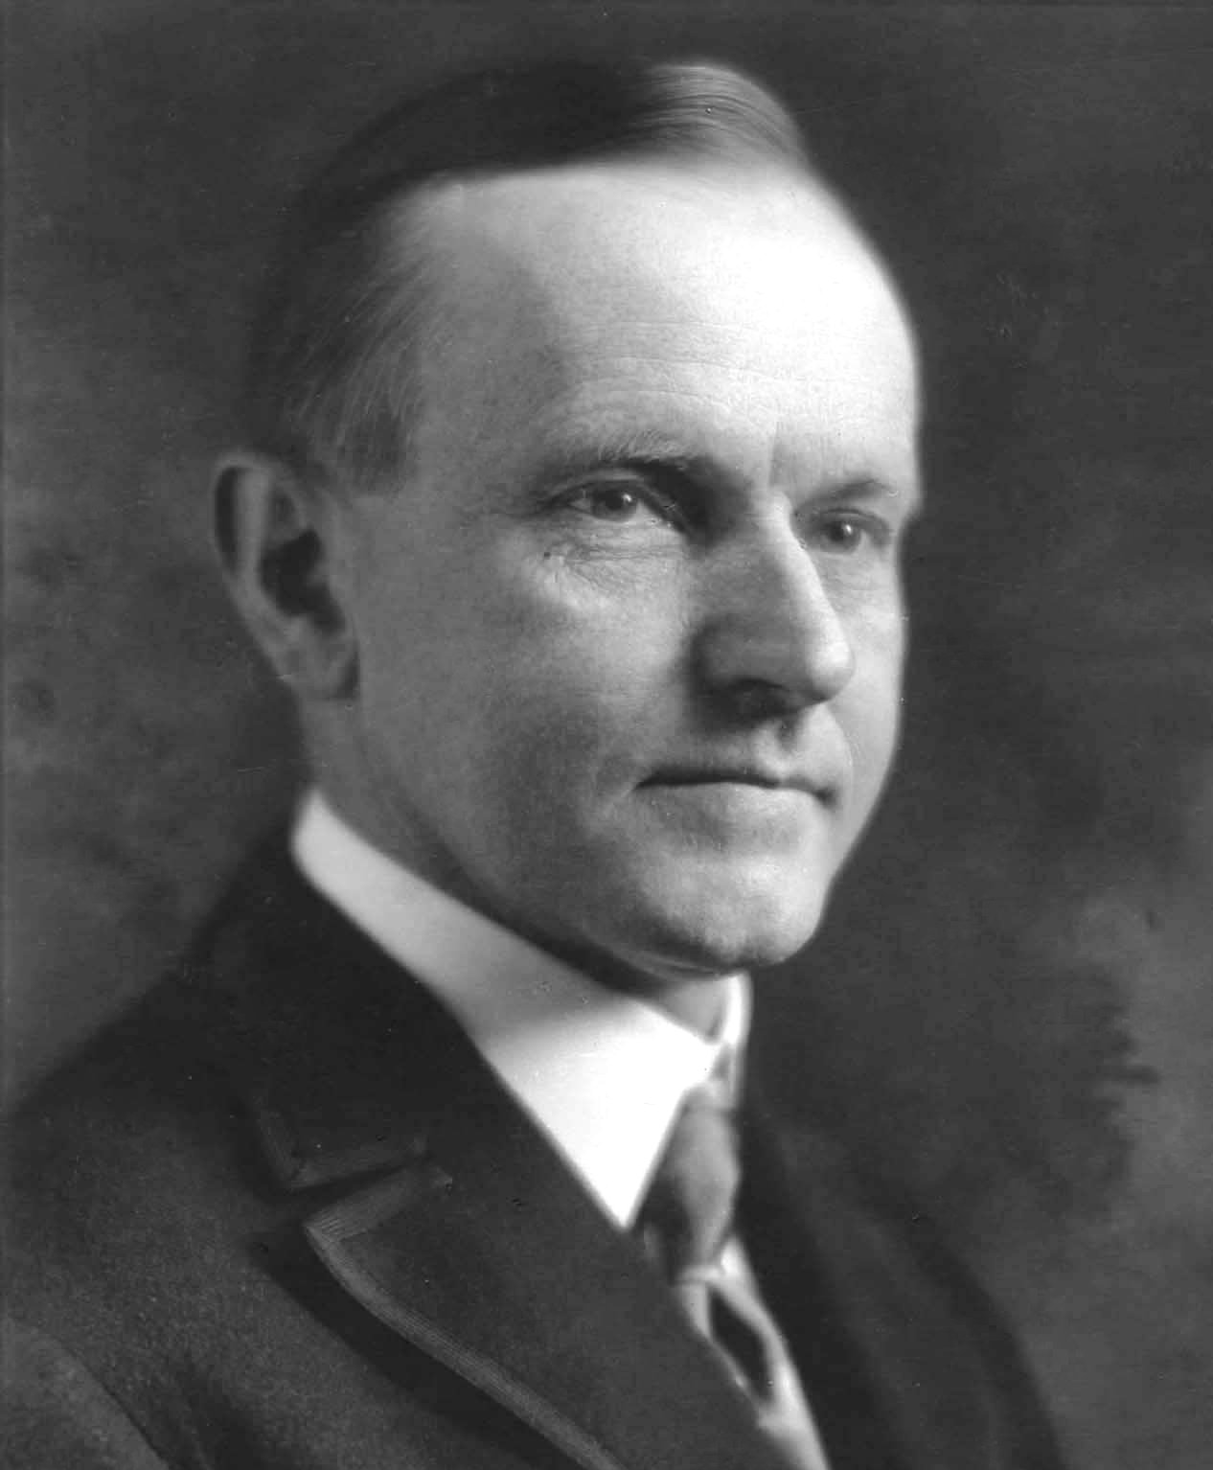 | 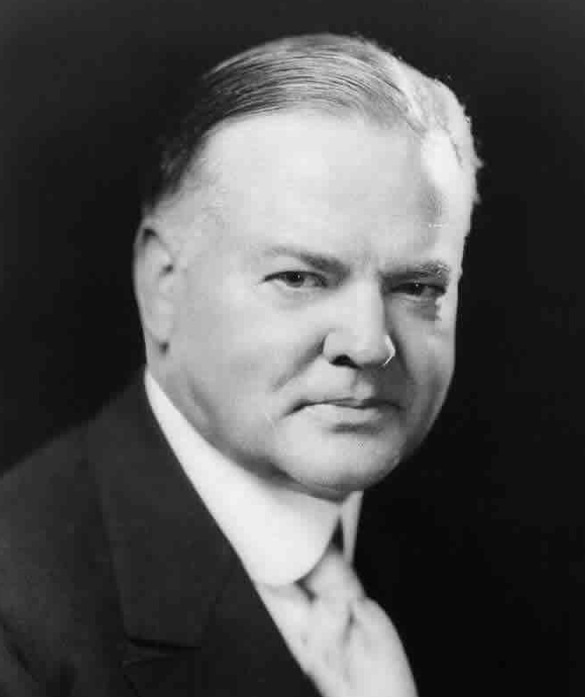

The Stock Market Crash

Bank Failures

The Business Cycle in Recession

International Trade Declines

Effects of the Great Depression:
Up or Down?

___ Unemployment
___ International trade
___ Homelessness
___ Value of stock market
___ Political unrest
___ Militancy of labor unions and strikes
___ Consumer demand for goods
___ Number of banks
___ Credit (availability of loans)
___ Migration of people from place to place
___ Foreclosures on farms and homes
___ Crime rate and suicide rate
___ Average wage/income

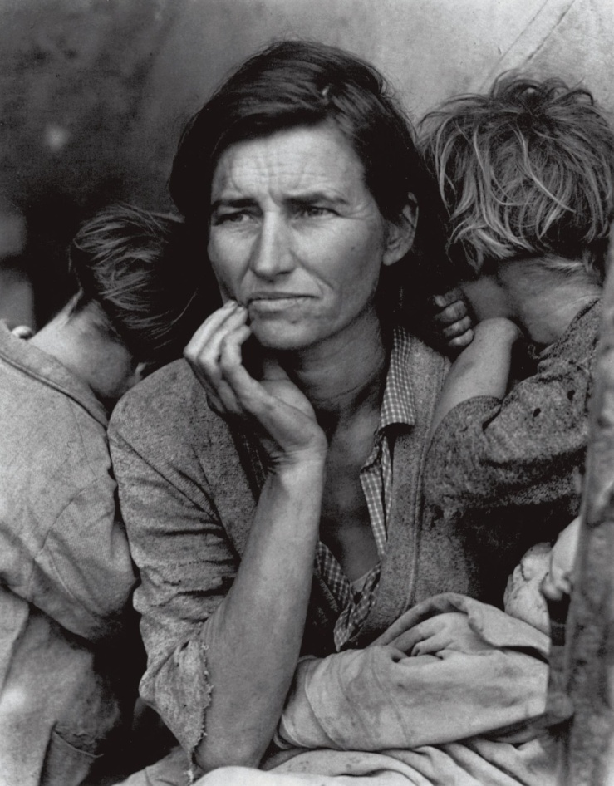

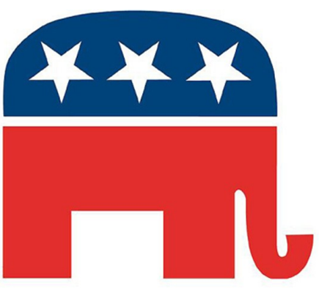
Contrasting Republican Policies

Issue | Progressive Era  1890-1919 | Roaring Twenties  1920-1929
Party
Leaders
Tariff policies

Regulation of big business
Labor

Civil Rights

Foreign Policy

Divisions & Scandals
Roaring Twenties Discussion Questions

- How did the 1920s expose tensions between new and changing attitudes on the one hand and traditional values and nostalgia on the other? Consider issues of
  - Gender
  - Religion & morality
  - Urban and rural America
  - Race, ethnicity and immigration
  - Economic policy
  - Technology and the sciences
- How did government policies of the 1920s encourage rapid economic growth? To what extent did these policies cause the Great Depression?
- To what extent should the government intervene in the economy?

